LEVEL-3
Organo-transition metal chemistry

TEXTBOOK REFERENCES:

- Housecroft & Sharpe Inorganic Chemistry Ch 23

2. Shriver & Atkins Inorganic Chemistry Ch 16

3. Elschenbroich & Salzer Organometallics - a concise introduction Chs 13, 14 & 15

4. Cotton & Wilkinson Advanced Inorganic Chemistry
5th Edition Chs 22-27

Level-3 Organometallics L1a

Brief history :

1825 - W. C. Zeise (Denmark) reacts Pt(2+) salts with ethanol. Originally formulated as KCl.PtCl₂.EtOH. In 1950's this was shown to be an olefin complex K⁺ [PtCl₃(CH₂=CH₂)]_ .H₂O
(see Organometallics (2001) 20 2)

1849 - E. Frankland (UK) synthesised first metal alkyl
3Zn + 3 C₂H₅I → ZnI₂ + ZnI(C₂H₅) + Zn(C₂H₅)₂
solid liquid
ZnEt₂ is pyrophoric - inert atmosphere required

1890 - L. Mond (Germany/UK) discovered metal carbonyls
Ni + 4CO ⇔ Ni(CO)₄
Soon after Fe(CO)₅ and Cr(CO)₆ sythesised

1930's - W. Hieber (Germany) worked on carbonyl chemistry of Fe
Fe(CO)₅ + en (ethylene diammine) → Fe(CO)₃(en) carbonyl substitution

Fe(CO)₅ + 2 OH⁻→ [HFe(CO)₄]_ carbonylate anion
+ H₃O⁺ → H₂Fe(CO)₄ metal hydride

1951 - Pauson synthesises ferrocene (C₅H₅)₂Fe - "sandwich"
1955 - E.O. Fischer (C₆H₆)₂Cr dibenzene chromium
1961 - Vaska shows Ir(CO)Cl(PPh₃)₂ reversibly binds dioxygen
1964 - E.O. Fischer makes first carbene (CO)₅W=C(OMe)Me
1973 - E.O. Fischer makes first carbyne (C₅H₅)(CO)₂W≡CPh
Level-3 Organometallics L1b

DEFINITION :
Organometallic compound contains a bond between a transition metal and an organic carbon

Nowadays vast numbers of different organometallics are known

Need to organise all this information in order to understand and
process

One way is by considering by ligands rather than by metals

Two major classes of ligands
(a) sigma-bonded

Examples alkyls M-CH₃ M-C₂H₅
aryls M-C₆H₅ (phenyl)
acyls M-C(O)-R e.g. acetyl
vinyls M-CH=CH₂
(b) pi-bonded
carbonyls M-CO
carbenes M=CR₂
olefins M(CR₂=CR₂)
cyclic olefins M(C₅H₅)

"Honary" organometallic compounds Pt(PPh₃)₄
Level-3 Organometallics L1c

Metal - sigma bonded compounds (metal alkyls)

Main group alkyls known from beginning ZnEt₂ PbEt₄ Quite stable
(thermodynamically !) but it was found that synthesis of transition metal alkyls was difficult - i.e. didn't work

Some exceptions Pope & Peachy (1901)
PtCl₄ + 3CH₃MgI → [(CH₃)₃PtI]₄ "cubane"

(C₅H₅)Fe(CO)₂(CH₃)

The latter type had π-acceptor ligands and it was thought that these might stabilise TM-C(alkyl) bonds

In 1950's several theoretical (MO) calculations showed that
TM-C(alkyl) bonds were especially weak due to poor overlap
between sp³ C and metal s p d orbitals. π-acceptor ligands were
"shown" to increase overlap and so stabilise these compounds.

However, all these calculations were incorrect. In fact TM-C(alkyl) bonds have similar strength to Main-group- C(alkyl) bonds

compare TiEt₄ v unstable decomposes at -80ºC
PbEt₄ stable to 200ºC
BUT Ti-C ~ 260 kJ mol⁻¹
Pb-C ~ 170 kJ mol⁻¹

Confusion between thermodyamic stability and kinetic stability
Level-3 Organometallics L1c
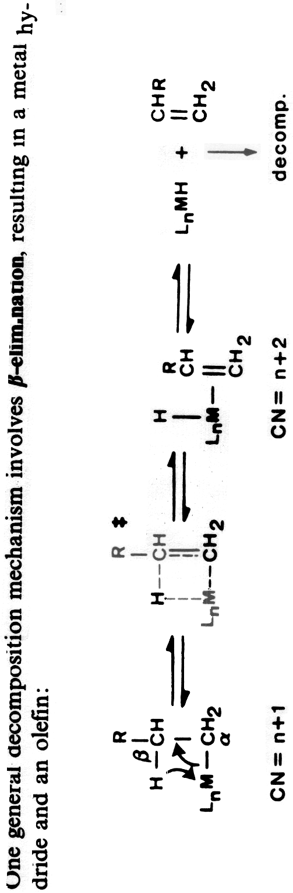
The general β-elimination mechanism
Level-3 Organometallics L2a

β-Elimination Mechanism

H/S p 603 E/S page 198 S/A 510 & 558

The β-elimination mechanism is the primary route for the decomposition of TM-alkyls where the alkyl group contains a β-H atom. It has a very low activation barrier if the transition state is
easily attained and means that most such TM-alkyls will spontaneously decompose.

The mechanism has four major requirements or consequences
- presence of β-H
- planar four-membered transition state
- vacant coordination site (more strictly vacant orbital on TM)
- alkene is formed as by-product

These features lead to ways in which this mechanism can be circumvented and lead to designed synthesis of stable TM-alkyls
Level-3 Organometallics L2b

β-Elimination Mechanism

(1) Use alkyls without β-Hydrogens

Alkyls with no β-hydrogens cannot decompose by this mechanism and are found to be much more stable

Common examples of such alkyls are :

-CH₃ (methyl) -CH₂Ph (benzyl) -CH₂CMe₃ (neopentyl)

-CH₂SiMe₃ (trimethylsilyl) perfluoroalkyls e.g. -C₂F₅

For instance Ti(CH₂CMe₃)₄ is stable above its boiling point of 90ºC
compared with TiEt₄ decomp above -80ºC

Perfluroalkyl complexes are particularly stable, in part due to the strength of the C-F bonds
Level-3 Organometallics L2c

β-Elimination Mechanism

(2) Absence of free coordination site

18-electron TM complexes do not have a suitable vacant orbital.
To generate one, it is necessary to lose one or more ligands.

Mechanistic studies show that in general, prior ligand dissociation is a requirement for an 18-electron compound to undergo β-elimination.

If ligands are strongly bonded, this may not be easy

EXAMPLE : CpFe(CO)₂(C₂H₅) Cp (cyclopentadienyl C₅H₅ )

Both the Cp and CO ligands are strongly bonded and this compound is reasonably stable - will decompose through loss of CO though at elevated temperatures.

EXAMPLE :
compare Rh(C₂H₅)(CO)₂(PPh₃)₂ unstable - Rh(1+) is 5 coordinate
[Rh(C₂H₅)(H₂O)₅]²⁺ stable - Rh(2+) is 6-coordinate

Stability as used here is relative stability.
Level-3 Organometallics L2d

β-Elimination Mechanism

(3) β-Hydrogens cannot become syn-coplanar

With bulky alkyl groups, it may not be sterically possible for the
β-H to get close to the metal

EXAMPLE - Cr(CMe₃)₄ is a reasonably stable tetrahedral metal alkyl. Although the tert-butyl group does contain β-H's, the bulkiness prevents these H-atoms from getting too close to the metal

EXAMPLE -
metal vinyl metal aryl
In both these examples, the sp² carbon requires 120º angles and the β-H cannot approach the metal.

EXAMPLE - here the transition state cannot become syn-coplanar because atoms are fixed in ring system.
Level-3 Organometallics L2e

β-Elimination Mechanism

(4) Absence of suitable alkene

Bredt's rule states that double bonds to bridgehead carbon atoms are highly unfavorable because of ring-strain. Since such alkenes are either unknown or unstable, their formation in a β-elimination is unfavorable. This gives high kinetic stability to alkyl groups such as 1-norbornyl

Tetrahedral complexes ML₄ These are known for Cr, Mn, Fe & Co - metals in +4 oxidation state which is very unusual for these metals.

Another reason why metal aryls cannot β-eliminate is that the corresponding alkene is in fact benzyne - a highly strained internal alkyne.
Level-3 Organometallics L2f

Synthesis of stable metal alkyl compounds

The ideas just given can be used to devise syntheses of stable TM-alkyls and other complexes containing TM-σ(C) bonds. The examples given also illustrate some important chemistry of organo-transition metal compounds.

(1) Metal halide plus Main group organoreagent

Best organoreagents (most reactive) are Lithium reagents LiR or
Grignard reagents RMgX

EXAMPLE
ZrCl₄ + 4 PhCH₂MgCl → Zr(CH₂Ph)₄ - tetrahedral complex

Also can use milder reagents such as R₂Zn or R₂Hg (note Me₂Hg is extremely poisonous) or R₄Sn

These will generally not replace all halides

EXAMPLE
NbCl₅ + (excess) Me₂Zn → Me₂NbCl₃

These may be useful to prepare mixed-alkyl complexes

Level-3 Organometallics L3a

Synthesis of stable metal alkyl compounds

(2) Metal hydride plus alkene

This is the reverse of the β-elimination reaction and is an example of the general insertion reaction. These involve insertion of small molecules into transition metal-X bonds. In this case that of an alkene into a TM-H (hydride) bond.

EXAMPLE
trans-(Et₃P)₂PtHCl + C₂H₄ → trans-(Et₃P)₂PtCl(C₂H₅)

In this example the resulting ethyl complex is stable because the d ⁸ platinum Pt(2+) atom strongly prefers square-planar geometry.

A related route is insertion of a carbene into a TM-H bond

EXAMPLE
CpMo(CO)₃H + CH₂N₂ → CpMo(CO)₃(CH₃)

CH₂N₂ is diazo-methane - an unstable molecule which acts as a source of the reactive intermediate "CH₂"
Level-3 Organometallics L3b

Synthesis of stable metal alkyl compounds

(3) Metal based nucleophile plus alkyl/acyl halide

This is closely related to the nucleophilic displacement reaction in organic chemistry
Nu⁻ + RX → NuR + X⁻

The nucleophile used are metal centered nucleophiles and are electron rich TM compounds. The most commonly used are metal carbonylate anions. Made with strong reducing agents such as sodium amalgam (Na/Hg)

EXAMPLE
Mn₂(CO)₁₀ + Na/Hg → 2 Na⁺ [Mn(CO)₅]⁻

Cleave Mn-Mn bond and reduce Mn to Mn(-1)

Na⁺ [Mn(CO)₅]⁻ + CH₃I → CH₃Mn(CO)₅

EXAMPLE
[CpFe(CO)₂]₂ + Na/Hg → Na⁺ [CpFe(CO)₂]⁻

C₂H₅I → CpFe(CO)₂(C₂H₅)
CH₃COCl → CpFe(CO)₂C(O)CH₃
acyl complex
Level-3 Organometallics L3c

Synthesis of stable metal alkyl compounds

(4) Oxidative addition of alkyl halide to 16 e⁻ complex
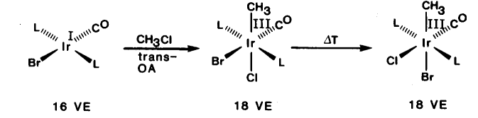
Many 16 e⁻ compounds with a d ⁸ or d ¹⁰ configuration react with alkyl halides

Metals undergo change of +2 in oxidation level. Very common for square-planar d ⁸ complexes

square-planar Rh(+1) Pd(+2) Pt(+2)
goes to octahedral Rh(+3) Pd(+4) Pt(+4)

Oxidative addition requires :
- metal has two accessible oxidation states differing by +2
- metal has vacant coordination sites

Also possible for zerovalent d ¹⁰ compounds
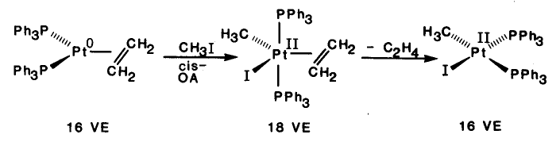
Level-3 Organometallics L3d

Reactions of metal alkyls

(1) Decomposition
Main route is by β-elimination. Experimental evidence to support mechanism :
- from labelling studies it is proved that β-hydrogen is transferred
(Bu₃P)CuCH₂CD₂Et → "(Bu₃P)CuD" + CH₂=CDEt
not detected
CH₂DCD₂Et

- necessity of vacant coordination site shown by inhibition of reaction with added PPh₃
CpFe(alkyl)(CO)(PPh₃) → CpFeH(CO)(PPh₃) + alkene

- best evidence comes from structures of alkyl complexes which show "agostic" interactions

Ti(dppm)Cl₂(CH₃) [CpCo(PR₃)(C₂H₅)]⁺
agostic methyl agostic ethyl

Level-3 Organometallics L3e

Reactions of metal alkyls

(1) Decomposition ......

Other routes are by α-elimination
EXAMPLE : WMe₆ → 3CH₄ + 3"W(CH₂)₃" (unknown polymer)

or by reductive elimination - reverse of oxidative addition

requires that groups eliminated are cis

(2) Insertion reaction
Many small molecules with multiple bonds (e.g. CO₂, CS₂, NO) will insert into M-C bonds. Most important is CO
EXAMPLE : (CO)₅MnCH₃ +CO→ (CO)₅MnC(O)CH₃ new acyl bond

Mechanistic studies show that
- the CO in the acyl groups comes from already coordinated CO
- incoming CO is cis to the acyl group
Level-3 Organometallics L3e

Reactions of metal alkyls

(1) Decomposition ......

Other routes are by α-elimination
EXAMPLE : WMe₆ → 3CH₄ + 3"W(CH₂)₃" (unknown polymer)

or by reductive elimination - reverse of oxidative addition

requires that groups eliminated are cis

(2) Insertion reaction
Many small molecules with multiple bonds (e.g. CO₂, CS₂, NO) will insert into M-C bonds. Most important is CO
EXAMPLE : (CO)₅MnCH₃ +CO→ (CO)₅MnC(O)CH₃ new acyl bond

Mechanistic studies show that
- the CO in the acyl groups comes from already coordinated CO
- incoming CO is cis to the acyl group
Level-3 Organometallics L4a

Complexes with unsaturated alkyl groups

Some alkyl groups have unsaturated functionality next at the α-C atom

These have possibility for π-bonding to metal atom. Structural evidence suggests this is not happening.

EXAMPLE trans-PtCl(PPhMe₂)₂R

obs Pt-C (Å) calc Pt-C (Å)
CH₂SiMe₃ 2.08 2.01
CH=CH₂ 2.03 1.98
C≡CPh 1.98 1.91

Unsaturated functionality can be bonded to another metal. example below is a bridging vinyl group

Level-3 Organometallics L4b

Complexes with π-acceptor ligands

There are many of these type of ligand (E/S Ch 15 S/A Ch 16)
Some bond to metal through one atom - described as η¹ (eta-one)
ligands, while others (described later) bind through more than one.

Examples of η¹ ligands

M-CO | M-PR₃ | M-CNR | M=CR₂ | M≡CR | M-CS | M-NO
carbonyl | phosphine | isocyanide  isonitrile | carbene  alkylidene | carbyne  alkylidyne | thiocarbonyl | nitrosyl

Conveniently classed together because bonding to TM is very similar in all cases - involves synergic bonding also called back-bonding

Evidence for back-bonding (E/Salzer pp 226-231)
- bond lengths increases the strength, hence reduces the length of M-C bond but decreases the strength, hence increases the length of the C-O bond. Not easy to see latter.
- C-0 stretching frequencies - this is very sensitive to extent of backbonding. For neutral (i.e. uncharged) complexes the range of frequencies allows distinction between terminal bridging and triply-bridging bonding
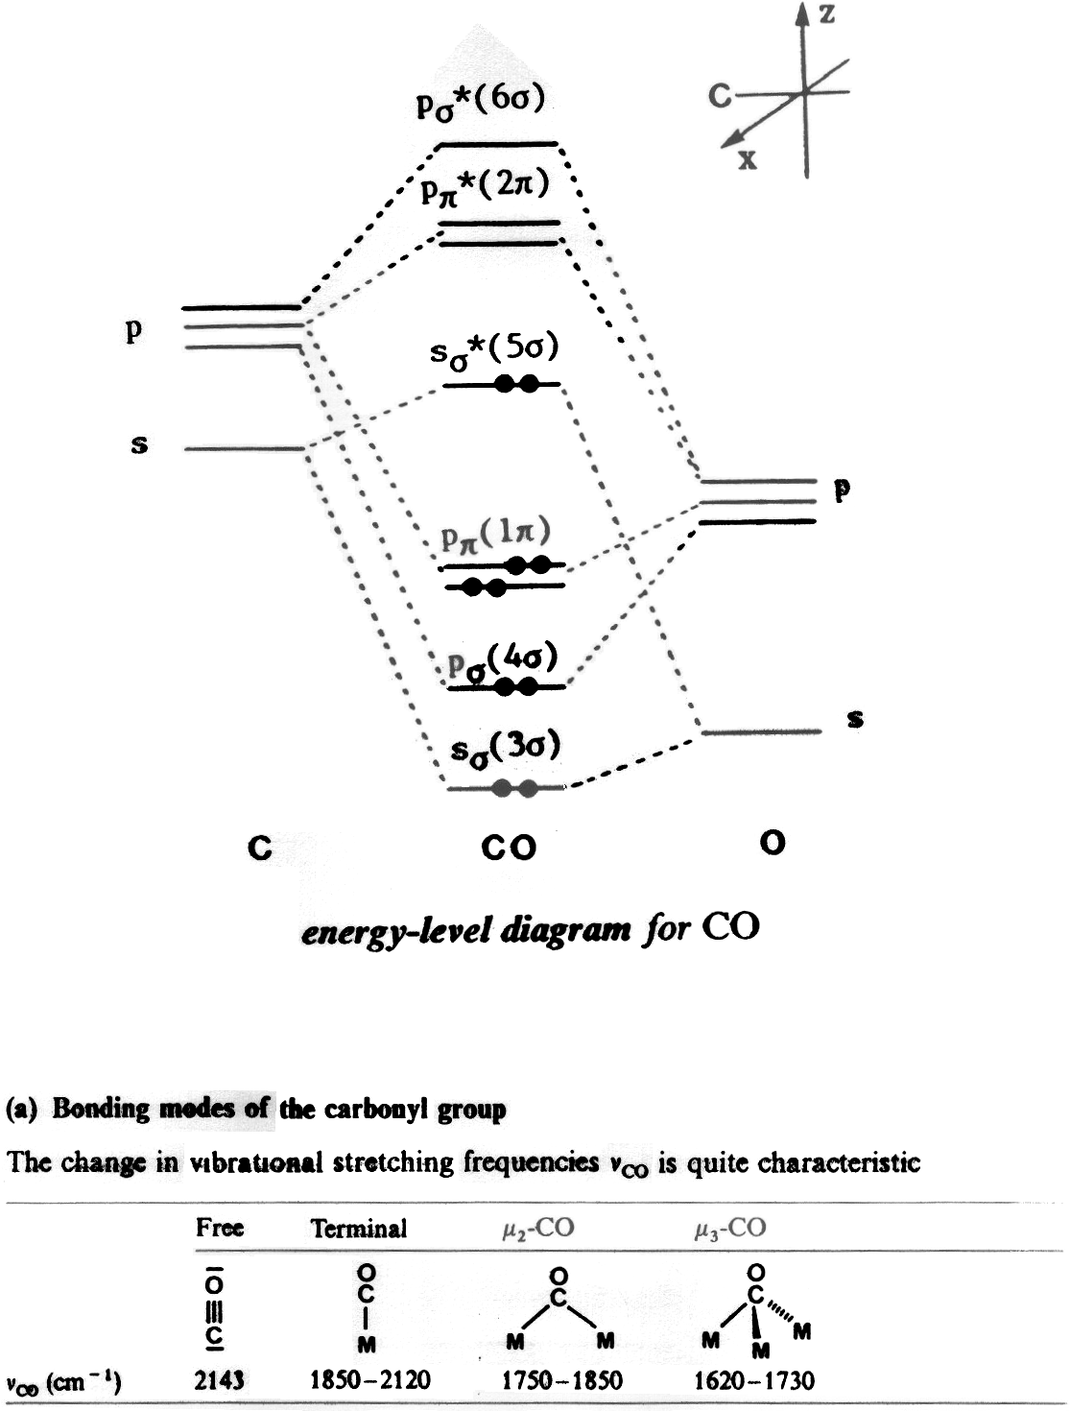
Level-3 Organometallics L4c

Level-3 Organometallics L4d

M-C bonding in CO complexes
There are three components to the bonding between CO and TM

(i) σ-donation from CO σ* level (5σ)
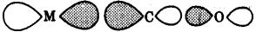
empty filled
M(σ) ← CO(5σ)

(ii) π-donation from CO 1π
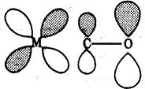
empty filled
M(π) ← CO(1π)

(iii) π-acceptor from metal to CO 2π*
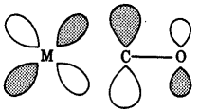
filled empty
M(π) → CO(2π*)
Level-3 Organometallics L4e

M-C bonding in CO complexes – the actual orbitals
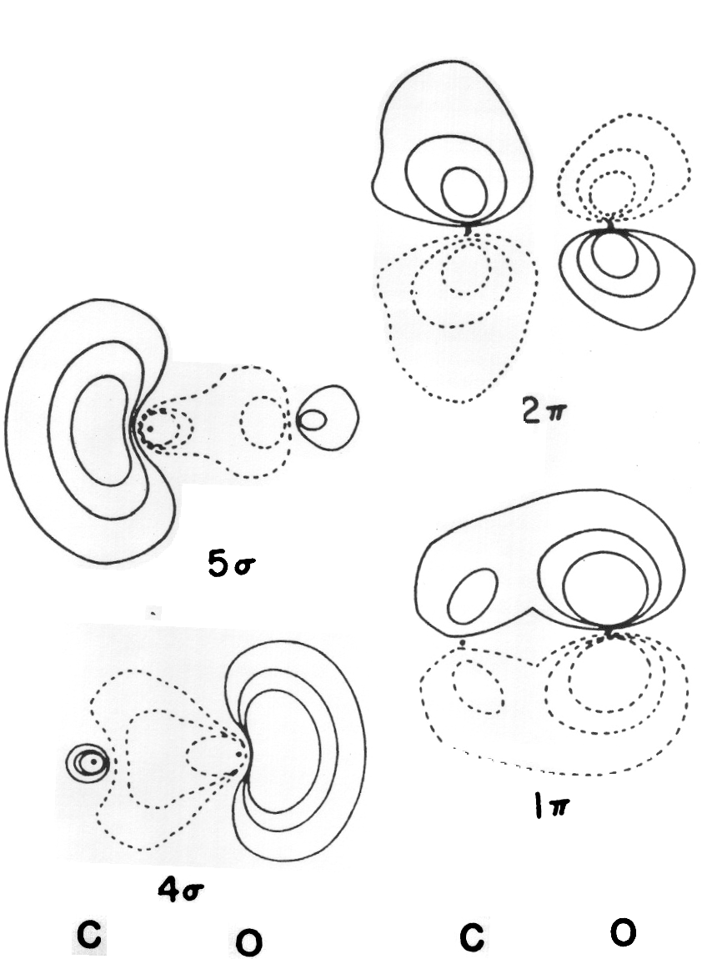

Level-3 Organometallics L5a
M-C bonding in CO complexes

All these interactions result in strengthening of the M-C bond.

Much evidence that this is case, e.g. for W-C distances
W(CO)₆ 2.06 Å WMe₆ 2.15 Å W(=CH₂) 1.94 Å

Difficult to separate effects of 3 components in metal complexes.

Evidence for σ-donor orbital (cases where no π-bonding is possible)
- Lewis adduct H₃B←CO. Complex has ν(CO) at 2164cm⁻¹ , free CO at 2143cm⁻¹ therefore C-O bond order is increased with σ-donation, as predicted.
- Same for cationic metal carbonyls e.g. linear [Hg(CO)₂]²⁺ ν(CO) 2164cm⁻¹ - only stable in highly acid solvents (CO is very poor σ-donor)

Back-bonding is very effective in reducing formal charge on a transition metal. Therefore CO is a very good ligand for stabilising metals in electron rich LOW oxidation states.

Charge on a complex has great effect on ν(CO)

complex | [V(CO)₆]⁻ | Cr(CO)₆ | [Mn(CO)₆]⁺
ν(CO) cm⁻¹ | 1860 | 2000 | 2090

Due to differing degrees of back-bonding.
Level-3 Organometallics L5b

Super-reduced carbonylate anions

CO can stabilise TM's in unusually low oxidation levels
EXAMPLE Mn₂(CO)₁₀ Mn(0)
Mn₂(CO)₁₀ + Na/Hg → [Mn(CO)₅]⁻ Mn(-1)

with stronger reducing agents (e.g. Na⁺ C₁₀H₈⁻) possible to get lower - super reduced carbonylate anions

Na⁺₃ [Mn(CO)₄]³⁻ Mn(-3) !!
Tetrahedral - unstable explosive

Other examples made in a similar fashion. Strong back donation shows in ν(CO) for series [M(CO)₄]^{n-}

 | Ni | Co | Fe | Mn | Cr
charge n | 0 | -1 | -2 | -3 | -4
ν(CO) cm⁻¹ | 2040 | 1890 | 1729 | 1670 | 1462

In -3 oxidation state M(CO)₅³⁻ V, Nb, Ta
M(CO)₄³⁻ Mn, Re
M(CO)₃³⁻ Co, Rh, Ir

In -4 oxidation state M(CO)₄⁴⁻ Cr, Mo, W
Level-3 Organometallics L5c

Super-reduced carbonylate anions

High negative charge is delocalised by carbonyl ligands

The formal high negative charge on the metals makes these ions extremely powerful metal-centered nucleophiles

EXAMPLES
[Mn(CO)₄]³⁻ + 2Ph₃SnCl → [Mn(CO)₄(SnPh₃)₂]⁻ (mono-anion)

[Mn(CO)₄]³⁻ + 3Ph₃PAuCl → Mn(CO)₄(AuPPh₃)₃

Level-3 Organometallics L5d

Other pi-acceptor ligands

The principles of bonding of CO to TM's applies in a very similar way to other π-acceptor ligands. However, there are always some differences/idiosyncracies

Dinitrogen (N₂)
Isoelectronic with CO, but not charge-polarised. Much poorer σ-donor and π-acceptor than CO.
Can bind in η¹-mode as M-N₂ but also bridging M-N≡N-M

Nitrosyl (NO)
Binds either terminal or bridging as CO.
Linear M-N-O angle 180-160º this is formal 3-electron donor
Bridging also 3-electron donor
Bent M-N-O angle 140-120º formal 1-electron donor

Isocyanide (RNC)
Isoelectronic with CO. Generally better σ-donor and poorer π-acceptor then CO, but this is a "tunable" ligand. Varying R-group
changes properties, i.e. electron donating R group e.g. CMe₃ make for better σ-donor, while electron withdrawing R-group e.g. CF₃ make for better π-acceptor

σ-donor and π-acceptor properties are synergic

Level-3 Organometallics L5e

Other pi-acceptor ligands

Phosphine/phosphite PR₃ P(OR)₃

Also AsR₃ (arsines) SbR₃ (stibines) SR₂ (thio-ethers)

Generally better σ-donor and poorer π-acceptor then CO, but again these are "tunable" ligand. Varying R-group changes properties.

How to separate σ-donor and π-acceptor properties ?

Not easy - use ν(CO) in compounds such as Mo(CO)₃(L)₃ as "indicator" of backbonding

L₃Mo(CO)₃ | ν(CO) cm⁻¹
L = PF₃ | 2055, 2090 | L very strong π-acceptor
L = PPh₃ | 1835, 1934
L = pyridine | 1746, 1888 | L is "pure" σ-donor

Note values of ν(CO) !!!

Using this, it is possible to "rank" ligands in order of π-acceptor strength
NO > CO > RNC > PF₃ > P(OR)₃ > PR₃

Level-3 Organometallics L6a
Alkene complexes - Dewar/Chatt/Duncanson model
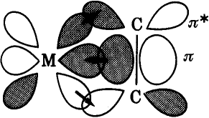
H/S 587-590 S/A 561-570 E/S 256-265
Two components
- σ-donation from alkene π-orbital to metal σ-orbital (s, p_{z} or d_{z2})
- π-donation from metal d -orbital to alkene π* orbital

Evidence for this model ?

1. Structural data
(a) bond distances
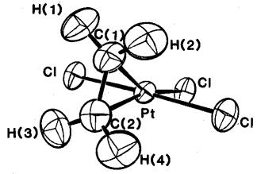
C-C distance = 1.37Å
C-C distance in free ligand = 1.35Å

Conclusion : in this complex most of bonding is ligand → M σ-donation
Zeise's salt [PtCl₃(C₂H₄)]⁻

Both components strengthen M-C bonds and weaken C-C bonds, but π-donation has greatest effect in weakening C-C bond

Level-3 Organometallics L6b
Alkene complexes - Dewar/Chatt/Duncanson model
(b) bond angles
When backbonding occurs, hybridisation of alkene C- atoms changes from sp² to approaching sp³. This has an implication for the bond angles (sp² C-atom is planar sp³ C-atom is pyramidal)

So - substituents "bend-back" from the metal - the greater the
π-donation the greater the bend-back.

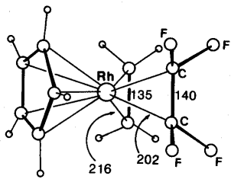
C-C distances C₂H₄ = 1.35 Å
C₂F₄ = 1.40 Å
Rh-C distances C₂H₄ = 2.16 Å
C₂F₄ = 2.02 Å
More π-donation in C₂F₄ ligand because F atoms are electron withdrawing.
CpRh(C₂H₄)(C₂F₄)
"Bend-back" angle C₂H₄ = 17º C₂F₄ = 37º
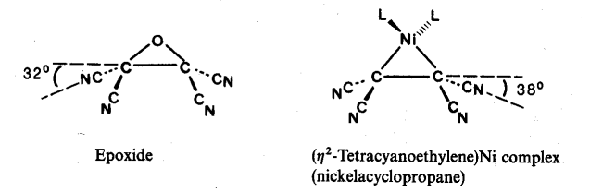

Alkene complexes can also be thought of as metallacyclopropanes
Two approaches are complementary.

Level-3 Organometallics L6c
Alkene complexes - Dewar/Chatt/Duncanson model

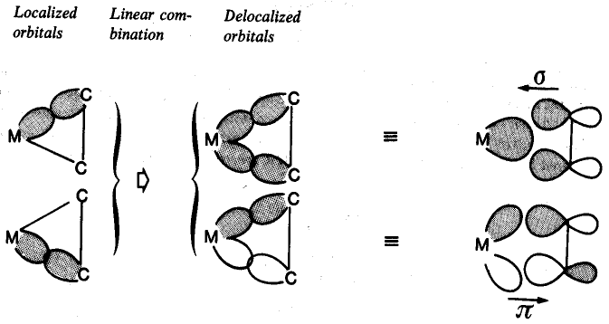
metallacyclopropane Dewar/Chatt/Duncanson

(2) Hindered rotation of coordinated alkenes

Alkenes can rotate about M-C=C axis
- M - alkene σ-bond is invariant to rotation (does not affect overlap)
- M - alkene π-bond is strongly dependent on rotation angle

Thus there is a energy cost (and hence a energy barrier) to this rotation. Barrier is of the size which can be detected by variable temperature NMR spectroscopy
Level-3 Organometallics L6d

Alkene complexes - Dewar/Chatt/Duncanson model
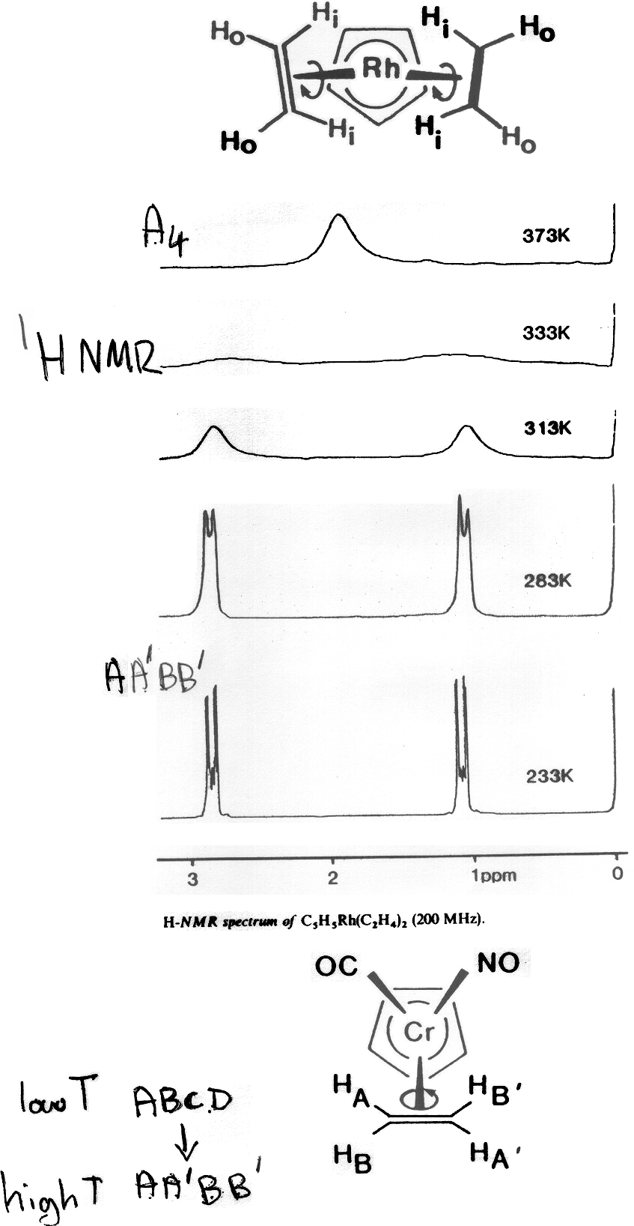
Level-3 Organometallics L6e

Alkene complexes - Dewar/Chatt/Duncanson model

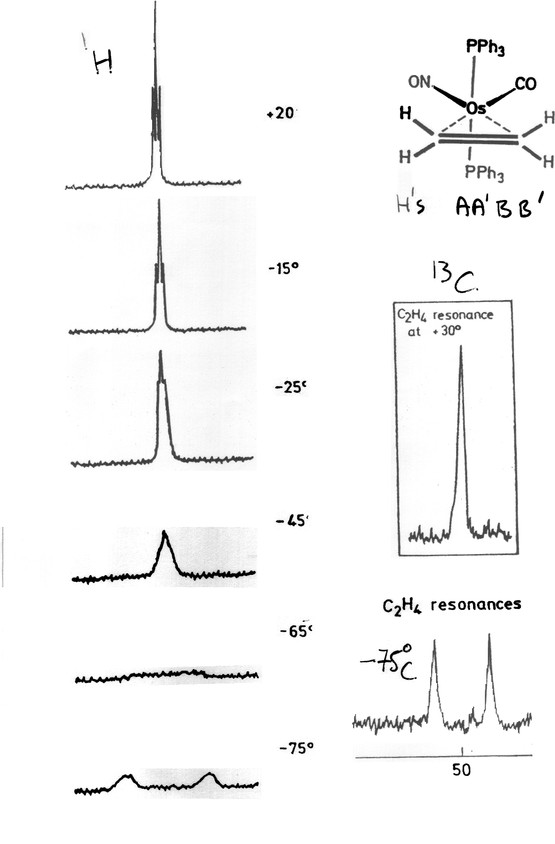
Level-3 Organometallics L7a
Metal hydride complexes

KReO₄ + K/EtOH → "K₂Re" white crystalline solid

Modern techniques X-ray, NMR not available. Compound actually contains the anion [ReH₉]²⁻ - an 18 electron complex !!
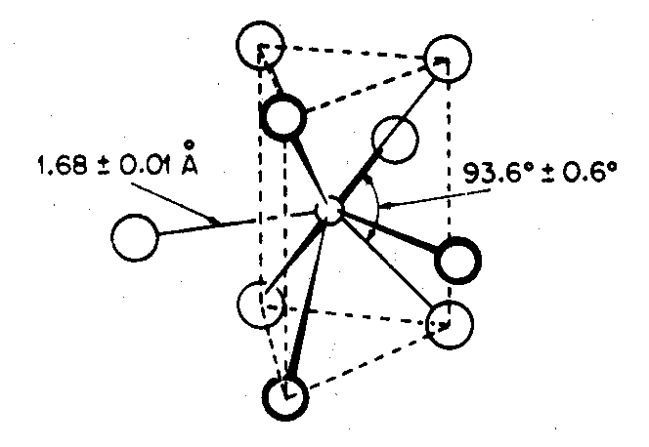
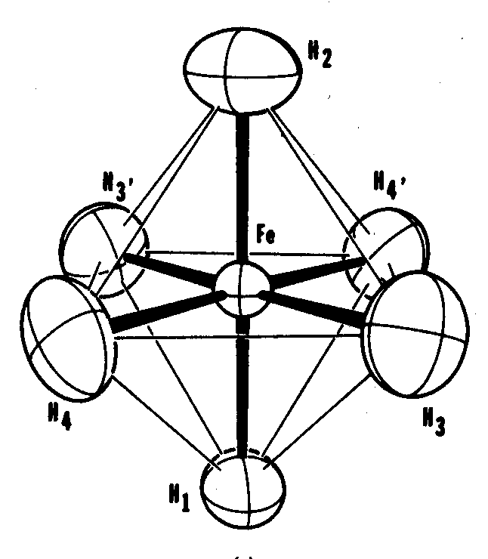

Only other well characterised pure hydride complex is Mg₂FeH₆
contains octahedral [FeH₆]⁴⁻ also 18 electron compound

Most hydride complexes contain other ligands, usually π-acceptor ligands like CO, C₅H₅ or phosphine PR₃

Earliest examples made by protonation of metal carbonylate anion.
Commonest way of making hydrides.

EXAMPLES
[Mn(CO)₅]⁻ + H⁺ → HMn(CO)₅ volatile yellow liquid δ(¹H) -7.5
stable at 0ºC
[Fe(CO)₄]²⁻ + 2H⁺ → H₂Fe(CO)₄ decomp -10ºC δ(¹H) -11.1
↓
Fe₃(CO)₁₂
Level-3 Organometallics L7b
Metal hydride complexes

How to detect metal-hydrides ?

- The negative chemical shifts in ¹H NMR are very diagnostic - no other type of H found here. Shielding due to non-local paramagnetic contribution from metal.

Terminal M-H δ -5 → -15 ppm
Bridging M-H-M δ -10 → -30 ppm

- M-H stretch in IR at ~ 2000 cm⁻¹ . Only CO stretches found in this region. M-H stretch first detected in Cp₂ReH.

For bridging hydrides M-H-M stretch is ~ 1600 cm⁻¹ and very weak and broad.

- Diffraction. X-ray not a lot of good since H atoms do not have much electron density.
Neutron diffraction much better - but serious drawbacks
(i) need neutron source - nuclear reactor
(ii) need very large crystals - difficult to grow
Level-3 Organometallics L7c
Metal hydride complexes

How are hydrides coordinated to metals ?

1. Terminal hydrides - normal coordination geometries
HMn(CO)₅

2. Bridging hydrides - very common in bimetallic and cluster compounds
[HFe₂(CO)₈]⁻

Has 3c-2e bond like B-H-B bond in boranes. This type of bonding has the effect of
- weakening Fe-Fe bond - longer than in [Fe₂(CO)₈]²⁻
- lowers metal-H stretch to ~ 1700 - 1500 cm⁻¹

3. Encapsulated hydrides - completely inside metal cage
[HCo₆(CO)₁₅]⁻ CW/5 p 1111 E/S p 408
δ(¹H) +23 ppm
Level-3 Organometallics L7d
Metal hydride complexes
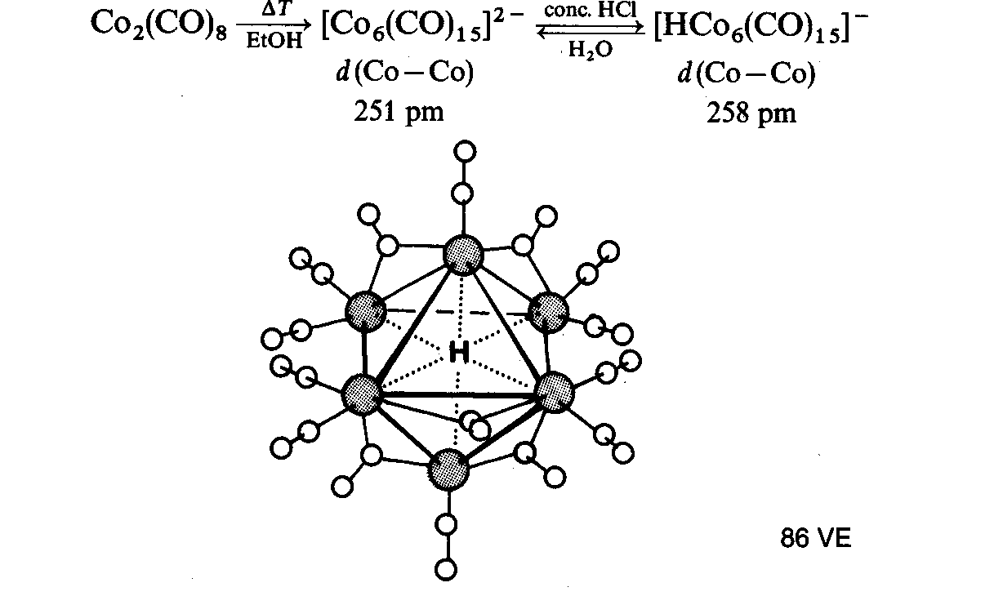
[HCo₆(CO)₁₆]⁻

4. Polyhydrides - many examples with Mo and W. Have unusual properties - very fluxional

e.g. WH₆(PR₃)₃ RuH₄(PR₃)₃

Because of small size, it is possible to pack several hydrides round metals in bimetallic polyhydrides
Ru≡R triple bond
Cp₂Ru₂H₄ Ru-Ru = 2.46 Å
normal Ru-Ru = ~ 2.9 Å

Some polyhydrides contains dihydrogen ligands
Level-3 Organometallics L7e
Metal dihydrogen complexes
RuH₄(PR₃)₃ is actually

most examples of dihydrogen compounds are octahedral

Bonding has σ-donation and π-backdonation components. Most important is σ-donation. Too much π-backdonation leads to breaking of H-H bond giving cis dihydride

How to characterise dihydrogen ligands ?

1. Diffraction
Neutron diffraction is definitive way - but not always possible to get suitable crystals
Level-3 Organometallics L7f
Metal dihydrogen complexes

2. Spectroscopic characterisation

In IR, the H-H stretch should give weak absorption at ~2400cm⁻¹

FeH₄(PEtPh₂)₃ has H-H 2380 cm⁻¹
and Fe-H 1880 cm⁻¹
but in RuH₄(PPh₃)₃ Ru-H 1942 cm⁻¹
H-H obscured

¹H NMR spectroscopy is better. Due to fluxionality it is NOT possible to see separate signals for H₂ and hydride ligands

Use the T₁ (relaxation time) criterion.
For hydrogen nuclei, relaxation is solely by dipole-dipole interactions with other H atoms
T_{1 ∝} r ⁶ (r is average H-H distance)

This is shorter for H₂ ligands H-H ~ 1.0Å
than for cis - dihydrides where H-H ≥ 1.6 Å

EXAMPLE for MH₄(PPh₃)₃ complexes (M=Fe, Ru, Os)
 | Fe | Ru | Os
T₁ (ms) | 24 | 38 | 820

Conclusion : Osmium compound contains classical hydrides, other two contain dihydrogen ligands.
Level-3 Organometallics L8a
Metal-metal bonded cage compounds

References : S/A pp 302-307 & 572-579
H/S pp 592-601 E/S Ch 16
Transition metals form three main classes of metal-metal bonded compounds
- Multiple bonded dimetal complexes (Dr Murrie)
- Halide/oxide clusters
- Carbonyl clusters

Halide/oxide clusters formed by early transition metals Nb, Ta, Mo, W, Re. Have halides and/or oxides as main (often only) ligands.

Examples of earliest known cluster compounds
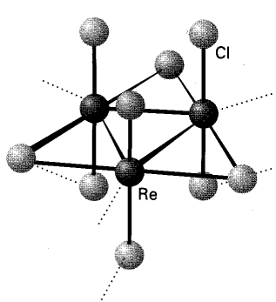
EXAMPLES

"ReCl₃" is really Re₃Cl₉

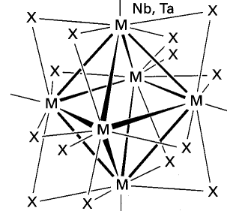
"NbCl₂" really contains [Nb₆Cl₁₂]²⁺
(chlorides bridge all edges)

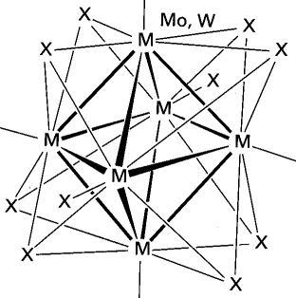
"MoCl₂" really contains [Mo₆Cl₈]⁴⁺
(chlorides bridge all faces)

Level-3 Organometallics L8b
Metal-metal bonded cage compounds

Carbonyl clusters
Many thousands of examples known. Contain metal atoms in low oxidation states (zero or below). Ligands are invariably π-accpetor ligands CO, PR₃, NO C₅H₅ etc .

Compounds are either neutral molecules or anionic. Virtually NO examples of cationic clusters

Number of metal atoms range from two upwards .....
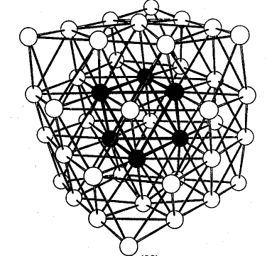

[Ni₃₈Pt₆(CO)₄₄H_{n}]⁴⁻ (CO ligands not shown)
This "cherry cluster" models a small metal particle with chemisorbed ligands - useful in understanding mechanisms of heterogeneous catalysis
Level-3 Organometallics L8c
Metal-metal bonded cage compounds
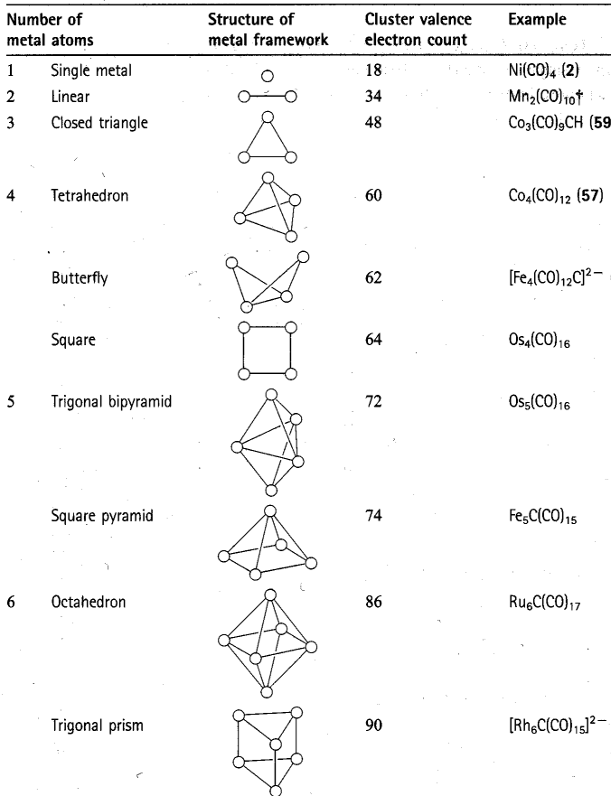
Level-3 Organometallics L8d
Electron counting rules

The "magic numbers" seen in previous overhead can be rationalised through Molecular Orbital theory in several ways

Leads to "electron counting rules" which relate the number of valence electrons to the skeleton structure of metals. e.g Wades rules

Compare [B₆H₆]²⁻ octahedron of BH units
with [Os₆(CO)₁₈]²⁻ octahedron of Os(CO)₃ units

Why related ? : both fragments have three orbitals for skeletal bonding.

[B₆H₆]²⁻ has 6×3 + 6 + 2 = 26 valence electrons
needs 6×2 = 12 for B-H bonds
leaves 14 electrons for B-B bonds
7 pairs (n+1) ≡ closo

[Os₆(CO)₁₈]²⁻ has 6×8 + 18×2 +2 = 86 valence electrons
needs 6×12 = 72 for Os-ligand bonds
leaves 14 electrons for Os-Os bonds
7 pairs (n+1) ≡ closo

Transition metals have 9 orbitals - 6 NOT used for cage bonds
Main group elements have 4 orbitals - 1 NOT used for cage bonds
Level-3 Organometallics L8e
Metal-metal bonded cage compounds
Electron counting rules

The polyhedra which Wades rules are based on are the so-called
deltahedral polyhedra - with triangulated faces
n = 4 Tetrahedron
n = 5 Trigonal bipyramid
n = 6 Octahedron
n = 7 Pentagonal bipyramid
.
n = 12 Icosahedron
These have the most number of nearest neighbour contacts and are the most favourable polyhedra (hence most stable).
http://mathworld.wolfram.com/Deltahedron.html

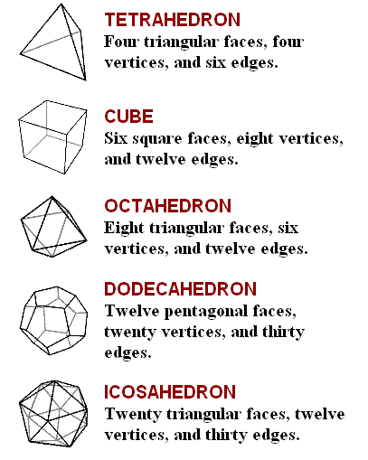
Some of these are also the Platonic solids (each face a regular polygon)
Level-3 Organometallics L8f
Electron counting rules
Example of nido cluster is Fe₅C(CO)₁₅
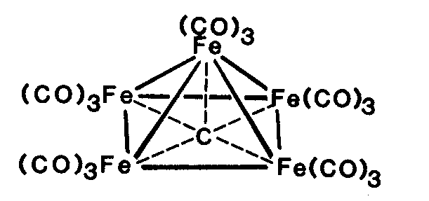

C atom is encapsulated - uses all its valence electrons and an acts as 4 electron donor

Organic chemists - note the 5-coordinated carbon atom !!!

Fe₅C(CO)₁₅ has 5×8 + 15×2 +4 = 74 valence electrons
needs 5×12 = 60 for Fe-ligand bonds
leaves 14 electrons for Fe-Fe bonds
7 pairs (n+2) ≡ nido
octahedron - one vertex

Example of arachno cluster is [Fe₄C(CO)₁₂]²⁻
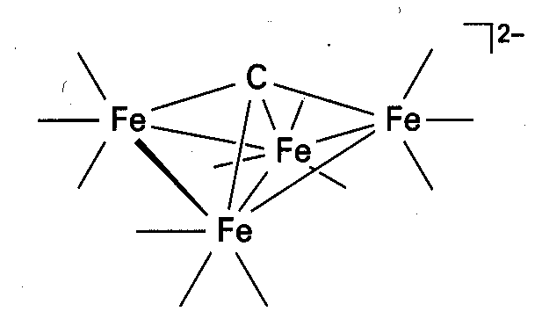

Fe₄C(CO)₁₂]²⁻ has 4×8 + 12×2 +6 = 62 valence electrons
needs 4×12 = 48 for Fe-ligand bonds
leaves 14 electrons for Fe-Fe bonds
7 pairs (n+3) ≡ arachno
octahedron - two vertices
also known as a "butterfly" cluster

