Level-3 Organometallics L1c
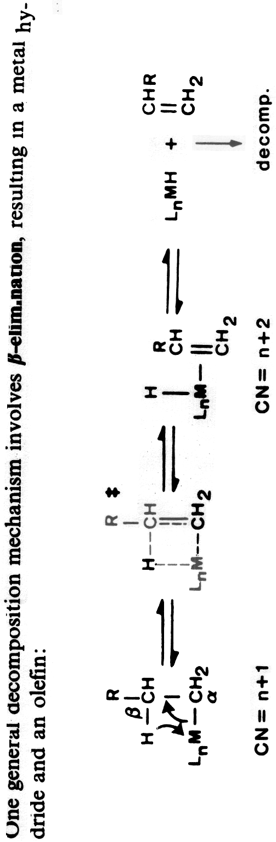
The general β-elimination mechanism

