Level-3 Organometallics L6a
Alkene complexes - Dewar/Chatt/Duncanson model
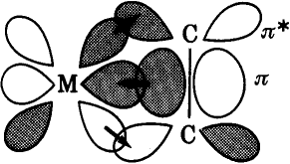
H/S 587-590 S/A 561-570 E/S 256-265
Two components
- σ-donation from alkene π-orbital to metal σ-orbital (s, p_{z} or d_{z2})
- π-donation from metal d -orbital to alkene π* orbital

Evidence for this model ?

1. Structural data
(a) bond distances
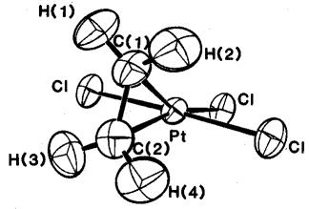
C-C distance = 1.37Å
C-C distance in free ligand = 1.35Å

Conclusion : in this complex most of bonding is ligand → M σ-donation
Zeise's salt [PtCl₃(C₂H₄)]⁻

Both components strengthen M-C bonds and weaken C-C bonds, but π-donation has greatest effect in weakening C-C bond

Level-3 Organometallics L6b
Alkene complexes - Dewar/Chatt/Duncanson model
(b) bond angles
When backbonding occurs, hybridisation of alkene C- atoms changes from sp² to approaching sp³. This has an implication for the bond angles (sp² C-atom is planar sp³ C-atom is pyramidal)

So - substituents "bend-back" from the metal - the greater the
π-donation the greater the bend-back.

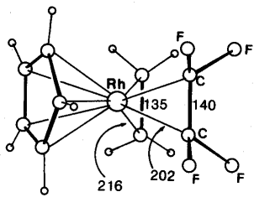
C-C distances C₂H₄ = 1.35 Å
C₂F₄ = 1.40 Å
Rh-C distances C₂H₄ = 2.16 Å
C₂F₄ = 2.02 Å
More π-donation in C₂F₄ ligand because F atoms are electron withdrawing.
CpRh(C₂H₄)(C₂F₄)
"Bend-back" angle C₂H₄ = 17º C₂F₄ = 37º
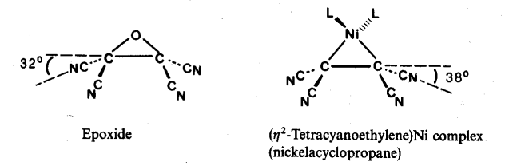

Alkene complexes can also be thought of as metallacyclopropanes
Two approaches are complementary.

Level-3 Organometallics L6c
Alkene complexes - Dewar/Chatt/Duncanson model

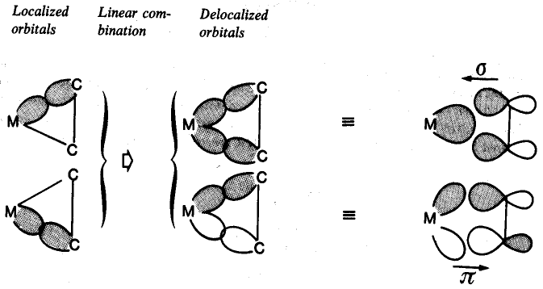
metallacyclopropane Dewar/Chatt/Duncanson

(2) Hindered rotation of coordinated alkenes

Alkenes can rotate about M-C=C axis
- M - alkene σ-bond is invariant to rotation (does not affect overlap)
- M - alkene π-bond is strongly dependent on rotation angle

Thus there is a energy cost (and hence a energy barrier) to this rotation. Barrier is of the size which can be detected by variable temperature NMR spectroscopy
Level-3 Organometallics L6c

Alkene complexes - Dewar/Chatt/Duncanson model
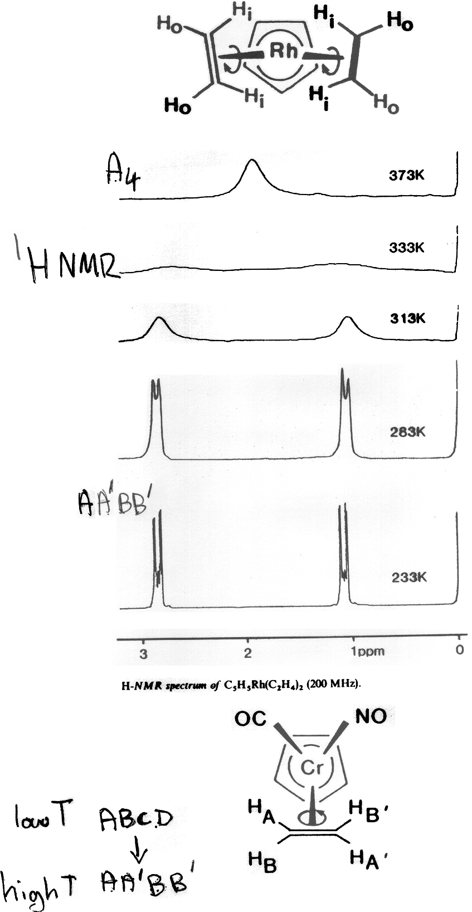
Level-3 Organometallics L6c

Alkene complexes - Dewar/Chatt/Duncanson model

