Level-3 Organometallics L8a
Metal-metal bonded cage compounds

References : S/A pp 302-307 & 572-579
H/S pp 592-601 E/S Ch 16
Transition metals form three main classes of metal-metal bonded compounds
- Multiple bonded dimetal complexes (Dr Murrie)
- Halide/oxide clusters
- Carbonyl clusters

Halide/oxide clusters formed by early transition metals Nb, Ta, Mo, W, Re. Have halides and/or oxides as main (often only) ligands.

Examples of earliest known cluster compounds
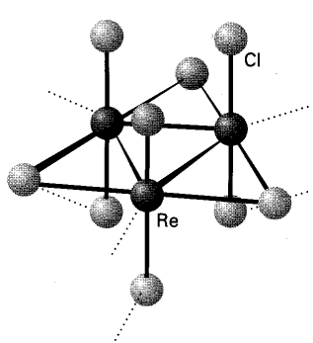
EXAMPLES

"ReCl₃" is really Re₃Cl₉

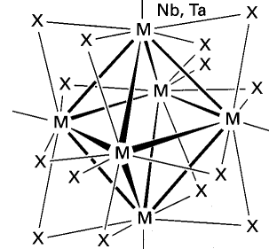
"NbCl₂" really contains [Nb₆Cl₁₂]²⁺
(chlorides bridge all edges)

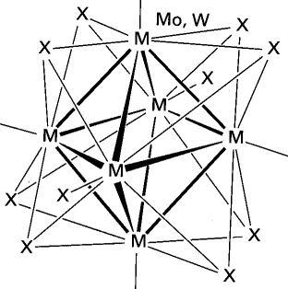
"MoCl₂" really contains [Mo₆Cl₈]⁴⁺
(chlorides bridge all faces)

Level-3 Organometallics L8b
Metal-metal bonded cage compounds

Carbonyl clusters
Many thousands of examples known. Contain metal atoms in low oxidation states (zero or below). Ligands are invariably π-accpetor ligands CO, PR₃, NO C₅H₅ etc .

Compounds are either neutral molecules or anionic. Virtually NO examples of cationic clusters

Number of metal atoms range from two upwards .....
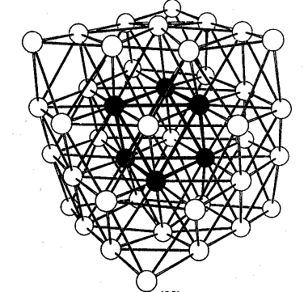

[Ni₃₈Pt₆(CO)₄₄H_{n}]⁴⁻ (CO ligands not shown)

This "cherry cluster" models a small metal particle with chemisorbed ligands - useful in understanding mechanisms of heterogeneous catalysis
Level-3 Organometallics L8c
Metal-metal bonded cage compounds
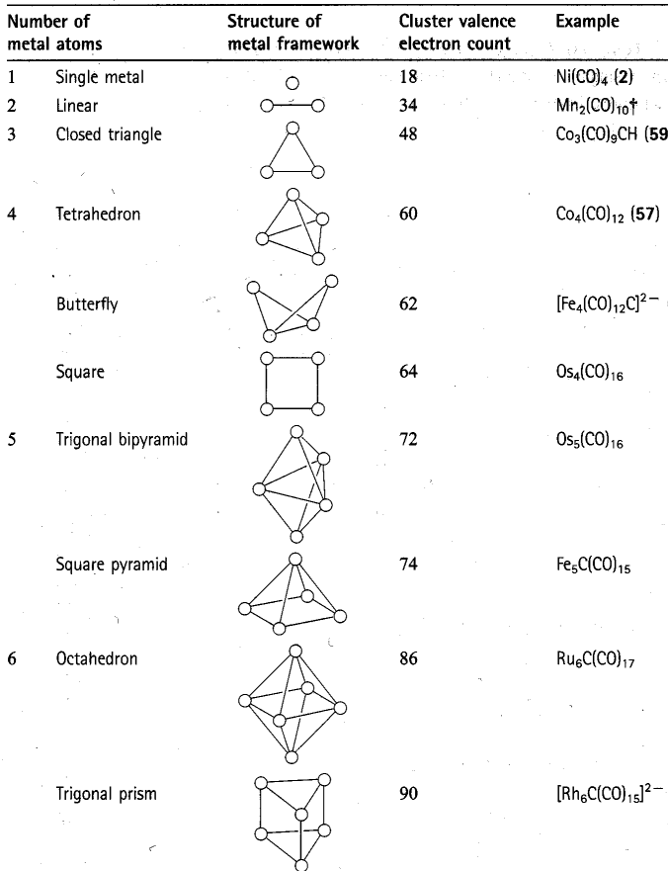
Level-3 Organometallics L8d
Metal-metal bonded cage compounds
Electron counting rules

The "magic numbers" seen in previous overhead can be rationalised through Molecular Orbital theory in several ways

Leads to "electron counting rules" which relate the number of valence electrons to the skeleton structure of metals. e.g Wades rules

Compare [B₆H₆]²⁻ octahedron of BH units
with [Os₆(CO)₁₈]²⁻ octahedron of Os(CO)₃ units

Why related ? : both fragments have three orbitals for skeletal bonding.

[B₆H₆]²⁻ has 6×3 + 6 + 2 = 26 valence electrons
needs 6×2 = 12 for B-H bonds
leaves 14 electrons for B-B bonds
7 pairs (n+1) ≡ closo

[Os₆(CO)₁₈]²⁻ has 6×8 + 18×2 +2 = 86 valence electrons
needs 6×12 = 72 for Os-ligand bonds
leaves 14 electrons for Os-Os bonds
7 pairs (n+1) ≡ closo

Transition metals have 9 orbitals - 6 NOT used for cage bonds
Main group elements have 4 orbitals - 1 NOT used for cage bonds
Level-3 Organometallics L8e
Metal-metal bonded cage compounds
Electron counting rules

The polyhedra which Wades rules are based on are the so-called
deltahedral polyhedra - with triangulated faces
n = 4 Tetrahedron
n = 5 Trigonal bipyramid
n = 6 Octahedron
n = 7 Pentagonal bipyramid
.
n = 12 Icosahedron
These have the most number of nearest neighbour contacts and are the most favourable polyhedra (hence most stable).
http://mathworld.wolfram.com/Deltahedron.html

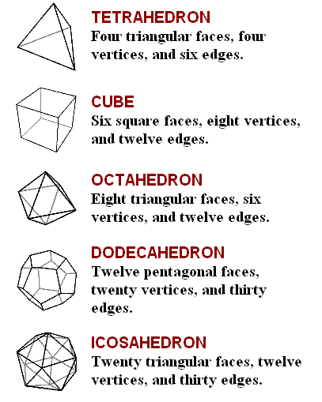
Some of these are also the Platonic solids (each face a regular polygon)
Level-3 Organometallics L8f
Metal-metal bonded cage compounds
Electron counting rules
Example of nido cluster is Fe₅C(CO)₁₅
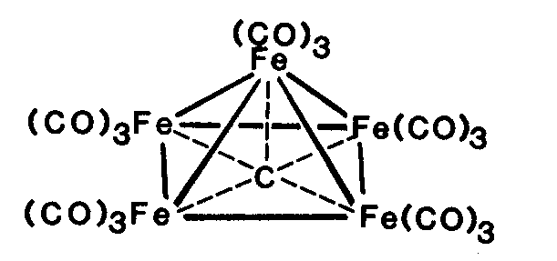

C atom is encapsulated - uses all its valence electrons and an acts as 4 electron donor

Organic chemists - note the 5-coordinated carbon atom !!!

Fe₅C(CO)₁₅ has 5×8 + 15×2 +4 = 74 valence electrons
needs 5×12 = 60 for Fe-ligand bonds
leaves 14 electrons for Fe-Fe bonds
7 pairs (n+2) ≡ nido
octahedron - one vertex

Example of arachno cluster is [Fe₄C(CO)₁₂]²⁻
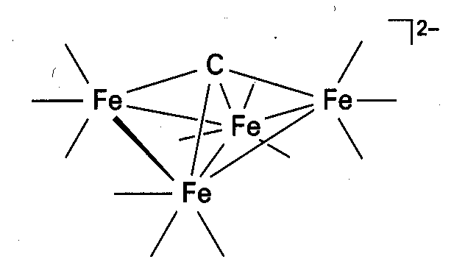

Fe₄C(CO)₁₂]²⁻ has 4×8 + 12×2 +6 = 62 valence electrons
needs 4×12 = 48 for Fe-ligand bonds
leaves 14 electrons for Fe-Fe bonds
7 pairs (n+3) ≡ arachno
octahedron - two vertices
also known as a "butterfly" cluster

