FULLPAT: A Full Pattern Quantitative Analysis Program for X-ray Powder Diffraction

Steve J. Chipera and David L. Bish,
Los Alamos National Laboratory, Mail Stop D469
Los Alamos, NM 87545
Chipera@lanl.gov
Bish@lanl.gov

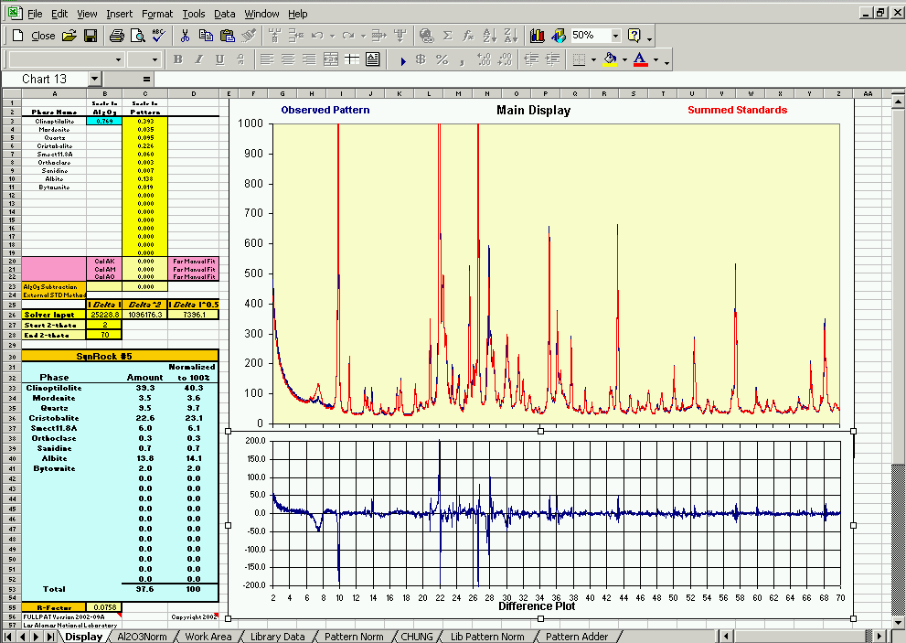

When reporting results obtained using this software, please include a citation to the following reference, which is currently accepted for publication in the Journal of Applied Crystallography.

Chipera, S.J. and Bish, D.L. (2002) FULLPAT: a full pattern quantitative analysis program for X-ray powder diffraction using measured and calculated patterns, J. App. Cryst. 35 (Accepted for Publication)

LA-CC-02-059

Table of Contents
INTRODUCTION: 3
THEORY: 4
Basic Theory 4
PROGRAM CONFIGURATION: 6
System/software requirements 6
Installation of FULLPAT 6
Layout of the Worksheets Composing FULLPAT 7
SOLVER Routine (least-squares refinement) 8
PREPARATION OF SAMPLES AND STANDARDS: 10
Preparation of Library Standards and Samples 10
Alternate Sources of Library patterns: 11
Creating Library Standards from diffraction patterns of pure phases 11
Sample mounting strategies 11
DATA COLLECTION: 12
USE OF PROGRAM: 12
Basic steps of a quantitative analysis: 12
Detailed Steps for Conducting a Standard Quantitative Analysis 13
A: Make a copy of FULLPAT 13
B: Import the Observed Sample Pattern into the PATTERN NORM worksheet. 13
C: Place observed data into the Work Area worksheet. 14
D: Add Library standards to the analysis. 14
E: Normalize (on corundum) library patterns to the observed pattern. 14
F: Conduct main analysis: 16
G: Examine the results 16
H: Reinvoke SOLVER 16
Accepting/Rejecting an Analysis 17
Expansion of Method to Conduct an External Standard Analysis 17
LIB PATTERN NORM: Normalize Pattern to be included in the FULLPAT Standard Library 17
PATTERN ADDER: Creation of a Library Standard From Alternate Data Sources 18
CHUNG: Traditional RIR or CHUNG Analysis 20
FUTURE MODIFICATIONS: 20
LEGAL STATEMENT: 20
REFERENCES: 21
APENDIX I: Phases Distributed in the FULLPAT Standards Library 23

INTRODUCTION:
X-ray powder diffraction has been the method of choice for both qualitative and quantitative phase analysis for over 50 years. Quantitative X-ray diffraction analysis (QXRD) is based on the fact that the intensities of diffraction peaks from a given phase are related to the phase’s abundance in a mixture. However, absorption effects usually prevent us from directly comparing peak intensities for a phase in a mixture with those from the pure phase prepared and run under similar conditions. Quantitative analysis methods were first proposed at least as early as 1936 (Clark and Reynolds, 1936), several publications in the mid 1970’s (e.g., Chung, 1974a,b; Hubbard et al, 1976) led to the common application of internal standards as a means of correcting for sample absorption/matrix effects. This work led to the Reference Intensity Ratio (RIR) method, one of the most widely used quantitative X-ray diffraction methods today (e.g., Pawloski, 1985; Bish and Chipera, 1988; 1995; Snyder and Bish, 1989; Chipera and Bish 1995).

Quantitative analyses using XRD saw a significant advance in the late 1980’s when the Rietveld method (Rietveld, 1969) was modified for quantitative analysis (Bish and Howard, 1986; Hill and Howard, 1987; and Bish and Howard, 1988). Shortly after the conception of the Rietveld quantitative analysis method, Smith and others developed a full-pattern quantitative analysis method based on the use of observed patterns, although their method can also use calculated or simulated patterns (Smith et al., 1987). Cressey and Schofield (1996) and Batchelder and Cressey (1998) also describe a similar full-pattern quantification method that involves manual fitting standard patterns to observed patterns collected using a curved position-sensitive (CPS) detector.

In an attempt to embody the best features of existing QXRD methods, we have formulated a new Microsoft EXCEL-based method that uses the entire powder diffraction pattern, including the background (Chipera and Bish, 2001; Chipera and Bish, 2002). The background contains important information on sample composition and matrix effects and its use also allows for the explicit analysis of amorphous or partially ordered phases such as glasses, organic materials, pharmaceuticals, and polymers. Like the Rietveld and Smith et al. methods, FULLPAT uses least-squares minimization to optimize the fit of the library standards to the observed pattern, thereby minimizing user intervention. Like the traditional RIR method, an internal standard is used to compensate for instrumental and sample matrix effects. The method can be easily applied to new systems and requires little crystallographic background.

FULLPAT is coded into Microsoft EXCEL using standard spreadsheet functions. As such, it should be readily transportable to any computer on which EXCEL is installed and can be readily modified by a user to meet their individual needs. In using FULLPAT, it is important to recognize that the quality of each analysis is strongly dependent on the quality of the standard library patterns. Given the variety of methods and instruments used in different laboratories, library patterns should generally not be shared between different laboratories. FULLPAT is distributed with only a limited number of example library patterns, as individual laboratories should measure their own standard patterns to ensure that the patterns are appropriate for their instrument and sample configurations. Finally, it should be pointed out that the principles incorporated into FULLPAT are not limited to X-ray diffraction but can be readily applied to other analytical methods (e.g., neutron diffraction and infrared spectroscopy).

THEORY:

Basic Theory
FULLPAT is based on the principle that patterns for each individual phase in a mixture can be added in the correct proportions to reproduce the observed pattern. A FULLPAT quantitative analysis varies the proportion of individual pure components using least-squares minimization to produce the best fit between an observed pattern and the simulated pattern produced by summing together patterns of individual pure components. Quantitative analysis is facilitated by adding a known amount of a corundum (Al₂O₃) internal standard to both library standards and unknowns. All individual library patterns are normalized on an equal-corundum basis so that the corundum in each library standard is at the same intensity as the corundum in the observed pattern, thereby removing instrumental and sample-related effects. Because the amount of corundum used in standards and unknowns is identical (20%), each analysis is reduced to nothing more than scaling and matching of corundum-normalized library patterns to the patterns of those phases in the observed pattern. The amount of a phase in the unknown mixture is equal to the amount the library standard must be scaled to match that phase’s portion in the unknown sample pattern. This is represented by equation (1):

I_{phase} = I_{std} * X%, (1)

where X% directly translates to the abundance of the phase in the sample. If all existing phases in the mixture are considered, summation of the individual phase-matches should result in an analysis total of 100% (i.e., Σ X_{phase} = 100%), even though the analysis is not constrained to sum to 100%.

Figure 1 graphically illustrates a FULLPAT analysis of a mineral mixture (SynRock#5) created by mixing known amounts of pure minerals. The observed pattern (a) was measured using normal instrument and analysis conditions. All individual library patterns were normalized on an equal-corundum basis so that the corundum in each library standard was at the same intensity as the corundum in the observed pattern. Individual library standards (b) for each phase observed in the sample were then simultaneously fit to the observed pattern. Determined phase abundances (scale factor) are indicated below each individual pattern. The appropriately fit and scaled library patterns can then be summed together to form a summation pattern (c). Subtracting the summed standard patterns from the original observed pattern produces a difference pattern (d), which is useful in assessing the goodness of fit for the analysis. Likewise, plotting the summed library standard patterns directly on the observed sample pattern helps assess the quality of the analysis. An additional benefit of superimposing the summation pattern onto the observed pattern is that any phases inadvertently omitted or previously unrecognized often become readily apparent.

The FULLPAT method explicitly fits both the background and diffraction peaks of each library standard to the background and diffraction peaks of the observed pattern. Thus, the background is a simple summation of the individual background components just as the diffraction peaks are. Background can be significant for disordered and amorphous materials and can also arise from other effects such as fluorescence from Fe-bearing materials when using a Cu-anode X-ray tube. By fitting the entire pattern including the background, amorphous components can be explicitly included in a FULLPAT analysis. Amorphous content is therefore no longer determined as the difference from 100% (i.e., %amorphous = 100% - Σ crystalline phases), which is now the case for most existing QXRD methods including the traditional RIR, Rietveld, and the Smith et al (1987) methods.
If all individual library standards are normalized to be equal on the basis of the intensity of their corundum internal standard, one can conduct an “external standard” or “adiabatic” analysis as described by Chung (1974b), without addition of an internal standard to the unknown. External standard analyses are performed by scaling each library pattern to match the observed pattern, thereby yielding relative percentages for all phases. As external standard analyses require the constraint that the abundance of all phases must sum to 100%, the relative percentages are normalized to sum to 100%. Most existing QXRD methods, including the traditional RIR, Rietveld, and the Smith et al (1987) methods, require that an internal standard be added to a sample for absolute quantification of amorphous-containing mixtures. Because FULLPAT explicitly fits the entire pattern, including the background and amorphous scattering, it is not constrained by this requirement. Thus, amorphous-containing mixtures can be successfully analyzed by FULLPAT using the external standard method as long as an appropriate standard for the amorphous component is included in the analysis.

FULLPAT uses least-squares minimization to optimize the fit between the standard patterns and the observed pattern, which is extremely important. Not only does this improve the quality of each analysis, it also removes a significant component of operator intervention, thereby giving reproducible results free of operator bias. To conduct the least-squares minimization, FULLPAT uses the SOLVER utility (supplied as a tool within EXCEL) that uses a non-linear programming (generalized reduced gradient) method. Further information on SOLVER and its functions can be found on the Frontline Systems Incorporated website (http://www.solver.com).

PROGRAM CONFIGURATION:

System/software requirements
FULLPAT was written using Excel and should be readily transportable to any machine on which Excel is installed. The spreadsheet is rather large (>11mb) so adequate disk space is needed, especially if every analysis is saved. Also, the least-squares refinement is computationally intensive so it is advised to use a fast CPU and sufficient memory. For example, a normal analysis of a geologic sample can often take several minutes on a computer with a Pentium III -1 GHz processor.

As FULLPAT makes use of macros for some cut-and-paste operations, the use of macros must be enabled in EXCEL. Likewise, FULLPAT uses the SOLVER utility that is supplied with EXCEL. In some versions of EXCEL, SOLVER is installed automatically during a default installation but it has not been tested to ensure that it is installed automatically with all versions and releases of EXCEL. If you find that SOLVER is not installed, go to the EXCEL HELP tab, and on the INDEX search option, type in either the key-word SOLVER or INSTALL and there should be a topic listing the details to load and install the SOLVER add-in. It may require that you run the EXCEL install/setup program again and go into the custom install menu and click on the SOLVER utility as one of the items to be installed.

Installation of FULLPAT
Very little is required to install FULLPAT. It exists as an Excel workbook and simply needs to be copied to the machine (which has Excel installed) where it is to be run. It is strongly suggested that original distribution be kept in a safe place and that the user conduct analyses using copies of the original distribution. When cutting and pasting data, it is easy to inadvertently delete or "corrupt" data links, equations, or operators.

Layout of the Worksheets Composing FULLPAT

The Excel spreadsheets that compose FULLPAT were designed to provide flexibility but still allow ease of use and manipulation. Cells highlighted in yellow are parameters that generally need to be modified by the user during each analysis. Bright yellow signifies a cell requiring user input and cells highlighted in the lighter yellow tone are possible options that the user may wish to invoke. Cells highlighted in light blue contain values that are either derived from other parts of the program or are passed between the various worksheets for further calculations and should NOT be edited by the user. Orange is used to highlight headings or titles and green is used to highlight general information. Cells with red triangles in the upper right corner have embedded information as comments in them. Move the mouse cursor over the cell to view the information.

A brief description of the worksheets that compose FULLPAT follows:

DISPLAY – user interface for variable input and display of plots and quantitative results.
This worksheet is the user interface for variable input and it displays the plots and quantitative results of the analysis. It contains a display window that shows the observed sample pattern and the pattern of the summed library standards and a difference pattern display window showing the difference plot between the observed and the summed library standards patterns. This sheet also contains the results of analysis. Currently up to 20 phases per sample may be analyzed, although more can easily be generated if necessary. It is from this worksheet that SOLVER is invoked to simultaneously fit all library standard patterns to the observed pattern.

AL2O3NORM – On the basis of corundum intensity, this worksheet normalizes the corundum peaks in the library pattern to the corundum peaks in the observed sample pattern.
This sheet is used to determine the proper normalization factor to apply to the library standards to scale them so that they have the same corundum intensity as the corundum in the observed sample pattern. This sheet contains four windows that the user can manipulate. The first three windows show the individual corundum peaks on which the user can normalize (43.3° peak region [40-48° 2θ]; 52.5° region [50-55° 2θ]; 57.5° region [55-60° 2θ]. The fourth window shows a more-expanded scale of 40 to 70° 2θ to observe the match for the entire sequence of higher-angle corundum peaks. The choice of several peaks to normalize against allows the user to choose a peak that is free from peak overlaps to obtain a more accurate fit.

WORK AREA – Area where the standard patterns to be fit to the observed pattern are placed and manipulated.
The user copies an observed pattern and each library standard to be included in the analysis into this sheet for manipulation by FULLPAT. Two columns are used for each library standard. Unaltered library data are pasted by the user from the reference standard library into the first column; manipulated library data (scaled data or data to which any other variables have been applied) are in the second column. This worksheet is also where all of FULLPAT’s calculations are conducted.

LIBRARY DATA – library of standard patterns.
This sheet contains of all standard library patterns. This sheet is completely independent and could reside as it’s own Excel workbook, which would be beneficial if the user is short on disk space and is retaining each analysis.

LIB PATTERN NORM – normalizes library standard patterns to equal corundum intensity.
This support worksheet normalizes new library standard patterns to an equal-corundum intensity basis. It is versatile in that it allows the user to normalize the pattern on any of five corundum peaks, thereby minimizing the effects of peak overlaps, etc.

PATTERN NORM – worksheet to input and preprocess observed sample patterns.
This worksheet is only for the convenience of importing data into FULLPAT. Its real strength is that it allows the user to do any required data preprocessing such as converting raw intensities to counts per second. Although this worksheet is not required for FULLPAT to function properly, it makes it easier to import data collected at differing count times or 2θ ranges.

PATTERN ADDER – used to generate standard library patterns from alternate pattern sources.
This support worksheet generates standard library patterns from alternate pattern sources if a standard pattern cannot be measured directly. It is used to add a pattern of a pure phase (calculated, simulated, or otherwise obtained) with a pattern of pure corundum (at a ratio that is determined by a required input RIR value) and it can also add a background component to the pattern if required.

CHUNG – used to calculate a phase abundance using the traditional RIR method.
At times, there may be a minor or trace phase in the sample that is not in the standard library pattern database. This worksheet allows the abundance for that phase to be calculated using the traditional RIR method (see Chung, 1974).

Table 1 summarized the various worksheets that compose FULLPAT, along with their size and linkages to the other sheets. Although many of the sheets are freestanding and may exist as their own separate files if disk space is an issue, the Display, Al2O3Norm, and Work Area sheets should all reside in the same file for ease of use as they have cross-linked references between them.

Table I. The worksheets that compose FULLPAT, their size, and relation to other sheets

Work Sheet | Size MB | Links to Other Sheets
Display | 0.1 | References to Al2O3Norm and Work Area
Al2O3Norm | 0.1 | References to Work Area
Work Area | 4.4 | References to Display, Paste from Pattern Norm
Library Data | 4.0* | Free Standing *grows with additional standards
Lib Pattern Norm | 0.8 | Free Standing
Pattern Norm | 0.3 | Free Standing
Pattern Adder | 0.5 | Free Standing
Chung | 0.1 | Free Standing

SOLVER Routine (least-squares refinement)
SOLVER is a least-squares refinement utility supplied with Excel. The utility has been set up to vary the proportion of each of the standard library patterns to minimize the cumulative errors between the observed and simulated patterns [difference pattern = (observed pattern – sum of library patterns)]. In order to minimize cumulative errors between an observed pattern and the pattern produced by summing individual library standards, we evaluated at least nine functions, all using unit weights, to determine which produced optimum results for standard mixtures. For each 2θ step in the pattern, the value Delta is defined as the difference between the observed intensity at that point and the intensity obtained by summing all library standard contributions to that point:

Delta = [Im(2θ) - Ic(2θ)] , (2)

where for each step or data point in the analysis, Im(2θ) = the observed intensity at an individual 2θ step, and Ic(2θ) = the intensity at that 2θ step obtained by summing all library standard patterns. Of the various functions investigated, we found that minimizing Σ|Delta| (equation 3) yielded the best results for known standard mixtures and also gave the best fits for both background and peaks. However, we also found that minimizing ΣDelta² (equation 4), which tends to emphasize fitting of peaks at the expense of background, also produced acceptable results and occasionally produced superior fits for minor phases. Functions such as √|Delta| (equation 5), which typically places more emphasis on background, produced slightly better results when analyzing samples containing poorly ordered or amorphous materials. All three minimization options are included in FULLPAT and it is written so that users can readily incorporate a minimization function of their own choosing.

Σ|Delta| = $\sum{}\left|[\text{Im}(2θ)\text{ - Ic}(2θ)]\right|$ (3)
ΣDelta² = $\sum{[\text{Im}(2θ)\text{ - Ic}(2θ)]}$² (4)
Σ√|Delta| = $\sum{\sqrt{}}\left|[\text{Im}(2θ)\text{ - Ic}(2θ)]\right|$ (5)

To assess the quality of fit for each analysis, the R-factor outlined by Smith et al. (1987) was incorporated into FULLPAT, where

R = $\frac{\sum{}\left|[\text{Im}(2θ)\text{ - Ic}(2θ)]\right|}{\sum{\text{Im}(2θ)}}$ . (6)

As reported by Smith et al., R-factors less than 0.20 and preferably less than 0.10 are considered to be representative of a good analysis. One of the strengths of the R-factor in assessing the quality of results is that it is normalized to the overall intensity of the pattern. Its value therefore has the same meaning between different patterns regardless of the quality of the patterns or how long they were collected. Minimizing the Smith et al. R-factor produced results comparable to those using equation 3. In certain cases, however, equation 3 produced slightly more accurate results for mineral-mixture standards.

FULLPAT has been extensively exercised using actual samples in order to evaluate the robustness of the fitting routine. The current parameters used with the SOLVER routine are as follows:

Mineral abundances are constrained to be less than or equal to 1.0.
A maximum iteration time of 300 seconds or 100 iterations is prescribed.
Precision is set to 0.000001
Tolerance is set to 5%
Convergence is set to 0.1
The SOLVER routine is set to “assume non-negative.”
Estimates are Quadratic
Derivatives are “Forward”
Search is “Newton”

Further information on SOLVER and its functions can be found on the Frontline Systems Incorporated website (http://www.solver.com).

PREPARATION OF SAMPLES AND STANDARDS:

Preparation of Library Standards and Samples
Sample preparation is perhaps the most important step in any quantitative phase analysis. General recommendations can be found in Bish and Reynolds (1989). The procedure used at Los Alamos in the geochemistry facility is to crush a large enough quantity of sample or standard in a shatter box to produce a representative homogeneous powder. To an aliquot of this powder (~0.8 g), 1.0μm metallurgical grade alumina powder (corundum) is added as an internal standard for both samples and standards in an 80:20 ratio (sample:Al₂O₃). This mixture is then ground under acetone in an automatic Retsch Micro Rapid Mill fitted with an agate mortar and pestle for grinding times of approximately 10 minutes. This procedure produces a powder with an average particle size of less than 3 to 5μm, which is desirable to ensure adequate particle statistics and to reduce primary extinction and ensures adequate mixing of the internal standard with the sample.

Each library standard and each sample has 20 wt% corundum added to it to remove sample matrix and instrumental effects. During an analysis, each library standard is normalized (scaled) to the unknown sample so that the corundum peaks in both the library standard and the unknown are at the same intensity. Likewise, all library patterns are normalized to the same scale (same corundum intensity). This way, only one corundum-normalization factor must be determined (corundum in the library standard to match corundum in the unknown) and the same normalization factor will apply to all library standards included in an analysis.

Homogeneous samples as close to 100% pure as possible are desired for standards. This is a trivial requirement for some minerals such as quartz, but it is difficult to impossible for others (e.g., zeolites and tridymite). We have obtained our standards from mineral supply houses, universities and museums, as reagent-grade chemicals, or from mineral separations of drill core and rocks. The purity of all standards was verified using X-ray powder diffraction. As it is often difficult to obtain 100% pure phases for use as library standards, slightly impure samples can often be used after conducting some data enhancement. The basic procedure is to obtain a pattern for the phase to be used as the library standard (with 20% corundum added) and subtract from it library patterns of the impurity phases (also with 20% corundum added). The result pattern now consists of the pure phase that also contains the appropriate amount of corundum as both the impurities and their associated quantity of corundum have been subtracted from the pattern.

Often times a crystalline substance may show variability in its diffraction pattern due to chemical and/or structural differences. For these phases, it is usually desirable to have more than one reference standard from which to choose. For example, two or more choices for kaolinite (a clay mineral) may be desirable, where one is well ordered with reasonably sharp peaks in the pattern and the other has significant disorder resulting in broader peaks and two-dimensional diffraction effects in its pattern.

Alternate Sources of Library patterns:
Ideally, each standard library pattern should be measured using representative materials similar to those in the samples being analyzed (possibly separated from the samples themselves). This way, the library standards match the phases in the unknowns in terms of structural order, peak widths, chemistry, preferred orientation, microabsorption, and numerous other sample related problems. There are a number of cases, however, where this is not possible. Frequently, problems are encountered obtaining pure standard material. Alternatively, a sample may be valuable or available only in very small amounts so that mixing with corundum is impractical. In such cases, provisions have been made in FULLPAT so that a diffraction pattern can be obtained from an independent source, subsequently adding the pattern of corundum in the proportion dictated by the calculated or reported (e.g., ICDD data) RIR dictates. Sources of patterns include laboratory-measured patterns of pure phases with no added corundum, calculated diffraction patterns (e.g., POWD10, Smith et al., 1983), simulated patterns from ICDD data, or patterns obtained from other laboratories.

Creating Library Standards from diffraction patterns of pure phases
Library patterns can be made from any diffraction pattern regardless of its source (measured, calculated, simulated ICDD patterns, etc.) by adding an appropriately scaled pattern of pure corundum to the pure pattern as is outlined in the section covering the Pattern Adder worksheet. The basic procedure is to take a pattern of a pure phase (obtained from another laboratory, calculated, simulated from ICDD data, etc.) and add to it a pure corundum pattern in an appropriated ratio as dictated by an RIR. If the pure-phase pattern is from a simulated ICDD card or is a calculated pattern, an additional required step is addition of an appropriate background. The background consists of two components. The first part is the elevation above the baseline such as results from fluorescence, and the second is composed of the low-angle scattering.

Sample mounting strategies
For XRD analyses, it is desirable to have as little preferred orientation as possible. Various methods can be used to prepare and mount samples to reduce preferred orientation. For a thorough discussion, see Bish and Reynolds, 1989.

1: Grind the sample as fine as feasible.
2: Use of back-packed mounts can somewhat reduce orientation effects.
3: Use of vibrated side-drifted mounts can greatly reduce orientation effects.
4: Spray dried sample agglomerates also greatly reduce orientation effects (e.g., Smith et al., 1979, Calvert et al., 1983, Hillier, 1999, 2000).

Although all of the above four options reduce orientation problems, the fine particle size specified in option one has additional benefits, including producing better quality sample mounts regardless of which method is used. It should be noted that the large agglomerates generated by spray drying (option 4) tend to be difficult to mount if the sample mount does not remain level during analysis (sample can roll out of the mount) and does not produce a flat surface. With vibrated side-drifted mounts, the sample must be vibrated into place (no tool inserted to pack the mount). If a packing tool is used, orientation of the particles can occur as a result of the sample being pushed against the various surfaces. With both side-drifted and the spray dried sample mounts, samples are not packed into the mount. This factor results in additional void space between particles, giving a sample mount that is less dense that often manifests itself as increased specimen transparency. Thus, although preferred orientation effects may be reduced, other deleterious effects such as peak broadening and peak shifts may result.

Although it is beneficial to reduce preferred orientation in the sample and standard patterns to produce a superior fit, reduction of preferred orientation does not, in practice, produce significantly improved results with full-pattern QXRD methods. Significant preferred orientation gives rise to a situation where some peaks have intensities that are overrepresentative of their abundance. However, there will also be peaks whose intensities are underrepresentative of their abundance. Consequently during the least-squares refinement with full-pattern methods, these effects tend to cancel each other, producing accurate quantitative results.

DATA COLLECTION:
The 2θ range used for data collection and analysis is largely dependent on the amount of time available. Currently we measure from 2-70°2θ, using 0.02° steps typically for count times varying from 2 to 90s/step. The only real limitation imposed by the current version of FULLPAT is that it requires a step size of 0.02° 2θ, although this could be readily reprogrammed if needed. Obviously, better-quality data over a larger 2θ range will usually produce better results. However, one can easily analyze a more restricted 2-θ range to cover only the major peaks for the phases in the sample and also collect data using short count times. Ultimately, if one is only interested in the abundance of a specific phase, one need only measure over a distinct peak for that phase and over a corundum peak, mimicking, in a way, a traditional RIR analysis. FULLPAT would still provide improved results, however, because peak overlaps and background effects are more accurately accommodated to produce more accurate and precise quantitative results.

USE OF PROGRAM:

Basic steps of a quantitative analysis:

The basic steps for conducting a quantitative analysis using FULLPAT are as follows:
- Obtain diffraction patterns for standard materials (library standards) using sample:corundum weight ratios of 80:20. These patterns can be measured or obtained as described above.
- Normalize all library standards to an equal-corundum-intensity basis.
- Measure unknown sample with 20% (by weight) added corundum.
- Identify the phases in the unknown sample.
- Choose the most appropriate standard phase from the library of standards for each phase present in the unknown sample.
- Superimpose the standard pattern for one of the more abundant phases onto the observed pattern and normalize the standard pattern so that the corundum peaks have the same integrated intensity as the corundum in the sample. This corundum normalization is applied automatically to all library patterns during analysis, as all library standards should have been scaled to equal-corundum intensity using the module Lib Pattern Norm.
- Finally, adjust the scale of the corundum-normalized library pattern for each phase in the sample so that it matches the observed pattern. This scale then becomes the phase abundance in the sample. This step is performed automatically by least-squares refinement during which all phase abundances are adjusted simultaneously, thereby producing the best fit between the summed library patterns and the observed pattern.

Detailed Steps for Conducting a Standard Quantitative Analysis

A: Make a copy of FULLPAT
Open the FULLPAT program in Excel and SAVE AS another filename (e.g., using the sample ID as the filename) so that you are not working with the original program. Because the use of FULLPAT involves cutting and pasting of data and due to the presence of embedded links between different cells in the worksheets, an important component or a data link can be inadvertently deleted.

B: Import the Observed Sample Pattern into the PATTERN NORM worksheet.
Sub-Step 1: The observed pattern is imported into the PATTERN NORM worksheet, column B.
These data can be cut from any text editor such as Notepad, Wordpad, Microsoft Word, etc. Use of the "Paste in XRD Data" button is suggested if the data are cut from a text file and are of the format:
Title in the first line
Data collected using 0.02°2θ steps (starting at 2°), listed one value per line starting on line 11 (extra blank lines are used in FULLPAT to shift patterns in 2θ space)
Functionally, the "Paste in XRD Data" button clears the data from column B and then pastes the data from the buffer into column B. Column A shows the 2-θ range for the data. If the input data started at a value other than 2°-2θ, they must be manually cut and pasted into the appropriate rows.

Sub-Step 2: Input into Cell A5 the count time per step (in seconds) used to collect the data so that the data can be normalized to counts per second (CPS). Although this step is not required for FULLPAT to function properly, it makes it easier to analyze multiple data sets collected at different count times.

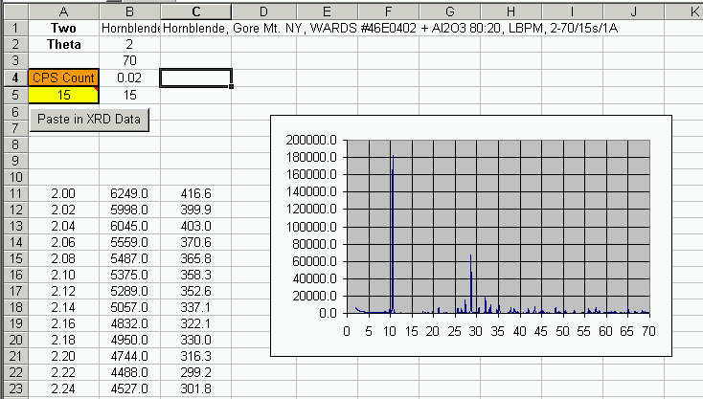
Column C is where the modified/manipulated data are placed. It is these data that will be copied into the Work Area worksheet to be used for the quantitative analysis in the following step.

C: Place observed data into the Work Area worksheet.
The observed sample pattern from the Pattern Norm worksheet, column C, now must be copied to the Work Area worksheet, column B, starting at row 7. The extra rows will be used for 2-θoffsets, which will be explained shortly. This step is best accomplished using the "Copy XRD Data from Pattern Norm" button in the Work Area worksheet. Functionally, this button clears the data from column B, pastes in the data from the Pattern Norm worksheet that you formatted in step B above, and then moves the cursor to cell B1 so that the sample ID for the analysis can be edited with the correct label for the sample being analyzed.

D: Add Library standards to the analysis.
For each phase in the sample, the appropriate library standard is copied from the Library Data worksheet into the Work Area worksheet. Simply select the whole column and copy (ctrl-c) and then select an empty column in the Work Area worksheet and paste in the data (ctrl-v). For determination of the proper scale factor for corundum fitting (which will be described in step E), it is strongly suggested that the standard data for one of the most abundant phases in the sample be placed into column C (the first column where library data to be included in the analysis can be placed).
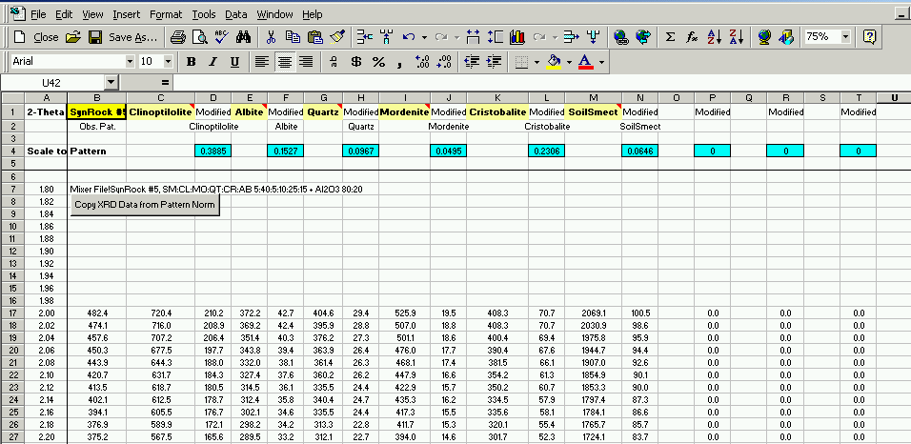
The first 17 data columns (columns C, E, G, I, K, M, O, Q, S, U, W, Y, AA, AC, AE, AG, AI) are used for phases whose abundances are to be refined by FULLPAT. The last three data columns (columns AK, AM, AO) are used for phases for which manual fitting is desired. There are times when a minor phase can be better fit manually better than by FULLPAT, for example, when one lacks truly representative standards and FULLPAT is using intensity for a minor phase to accommodate mismatches between the standards and other phases in the sample.

E: Normalize (on corundum) library patterns to the observed pattern.
The appropriate scale factors for the library standard patterns are determined by normalizing the intensity of the corundum in the standard patterns to the corundum in the observed sample pattern using the AL2O3Norm worksheet. The library pattern located in column C of the Work Area sheet is used for this analysis, and it is important that this be the pattern for a phase that is abundant in the sample, in order to compensate for and match matrix, background, and peak-overlap effects.

To obtain the best possible fit for matching the corundum scale factor in this analysis step, the peaks (library standard and observed pattern) should overlap as closely as possible in terms of 2θ. It may be necessary to shift one of the patterns (if necessary, it is preferable to shift the observed sample pattern) one or two steps, one way or the other, in 2θ space. This is best accomplished by selecting the data for the observed pattern (Work Area, row cells 17:3417) copying them (ctrl-c) and pasting them back either one cell up or down (ctrl-v) until the desired 2θ match is obtained.
A general WARNING: to conduct the manual shift, the data must be “COPIED” from the worksheet and “PASTED” into the appropriate shifted position in the Work Area sheet. If a CUT and PASTE operation is conducted, links and cell references also move.

The next step in analysis is to use the Excel function, SOLVER, (the least-squares routine) to obtain the appropriate scale factor so that the intensity of the corundum in the library standard pattern matches that of the corundum in the observed sample pattern. The two parameters varied by solver are the scale factor of the library standard and the scale factor of a constant background. Although it is true that the final background in an analysis should match identically when all phases are included in the analysis, (as the calculated mixture now has the same chemical and mineralogical makeup as the unknown), a single individual library pattern will not have the same chemical makeup and will require some background offset due to chemical variation and other effects (e.g., fluorescence).

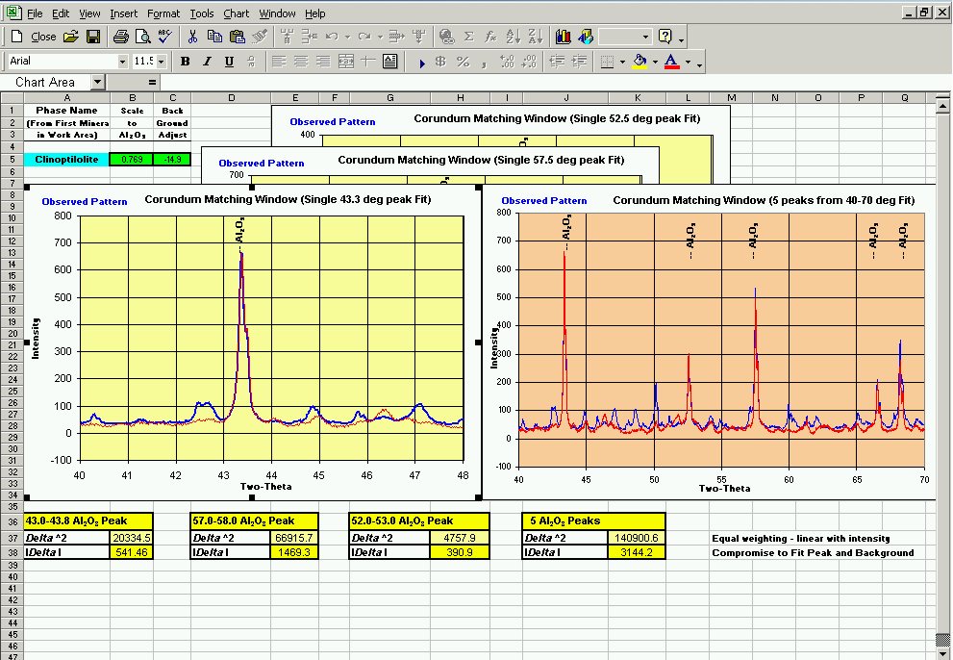

To invoke solver, select TOOLS, then SOLVER. If SOLVER is not an option, make sure that the cursor has not selected a chart but is clicked instead on a cell in the worksheet. The "Set Target Cell" is the cell that you are solving for and it will accept whichever corundum peak the user chooses to solve on. The scale factor determined using SOLVER is then passed onto the Display worksheet (Cell B3) and is used to normalize all library patterns during quantitative analysis so that they all are equal to the sample pattern on the basis of the intensity of the added corundum internal standard.

F: Conduct main analysis:
Now that initial setup is complete, it is time to conduct the main analysis. FULLPAT is fairly robust but there are several things that can be done to improve and/or speed up the analysis. A rough outline of steps follows:

1: Ensure that all mineral abundances are set to zero (cells C3:C22).

2: For each phase, one at a time, manually input abundances until a rough match between the library standard and that phase in the sample is obtained based on visual inspection. Although this step is not necessary, it minimizes the time it takes FULLPAT to determine an optimal solution.

3: Inspect the 2θ match between each library standard and the respective phase in the sample. If significant mismatch exists, shift the library pattern in 2θ space (COPY and PASTE intensity data in the Work Area sheet) in the same fashion as discussed in E above. Presently, 10 lines at the beginning and end of each data column have been provided to allow for manual shifting of patterns. These lines allow for a manual shift of up to 0.2°2θ (10*0.02° step), which should be sufficient for a properly aligned diffractometer.

4: Invoke SOLVER by selecting TOOLS, then SOLVER. If SOLVER is not a possible option, make sure that the cursor has not selected a chart but is clicked instead on a cell in the worksheet. The "Set Target Cell" is the cell that contains the parameters for which you are solving (designated in FULLPAT in a yellow "user to choose" box, Cells B26, C26, or D26). It is advisable to run SOLVER several times until the value being minimized does not reduce significantly, as the non-linear methods used by SOLVER are known and expected to drop into false minimas.

G: Examine the results
At this stage in the analysis, the results of the fit should be examined to assess the quality of the fit and to make any necessary adjustments. It is at this point that any phases that were not included in the analysis will become obvious in both the Main Display and Difference plots as unaccommodated peaks. Likewise, FULLPAT may be using a minor or trace phase to accommodate intensity mismatch elsewhere in the pattern. If the user has knowledge about that phase (e.g., intensity mismatch for a well-resolved peak) they may wish to manually fit the data for that phase. The first 17 data columns are used for phases whose abundances are to be refined by FULLPAT. The last three data columns are used if manual fitting is desired. Go to the Work Area sheet and COPY (do not cut!) the data for the phase where manual fit is desired and paste it into column AK, AM, or AO. Then COPY a blank column and paste it over the column of the phase that you just copied. (Remember, Do not use CUT and PASTE as it also moves all of the links).

H: Reinvoke SOLVER
Again, invoke SOLVER and re-examine the results to see if they are satisfactory.

Accepting/Rejecting an Analysis
It is up to the individual analyst do assess the quality of an analysis. Careful examination of the resultant fit is required to ensure that no phases were missed in the analysis or that a phase has not been over or under calculated.

Expected behavior suggesting that the analysis worked properly:
- The sum of all the scaled library patterns should match the observed pattern reasonably well, with the scales of all of the components summing to ~100%.
- The corundum peak resulting from the sum of the individual patterns should also match the observed pattern (20% corundum added to both the library standards and the unknown samples).
- The background generated in the summed patterns should match the background of the observed background. (Glass and/or amorphous components can be explicitly added as library standards to create a better fit to observed patterns, thereby eliminating the "difference-from-100%" constraint).

Expansion of Method to Conduct an External Standard Analysis
Running FULLPAT without adding a corundum internal standard to a sample is analogous to the external-standard (adiabatic) method described by Chung (1974b). This method requires the assumption that the sum of all phases equals 100%. The advantage of FULLPAT over traditional Chung external-standard analyses is that FULLPAT fits the entire pattern, including the background, which now allows us to explicitly fit poorly ordered or amorphous phases. In most other QXRD methods, amorphous phases can only be calculated by difference from 100% (i.e., amorphous = 100 - sum of crystalline phases) and only when an internal standard had been added to the sample.

FULLPAT has several features that help accommodate external standard analysis. The results section on the DISPLAY worksheet has a column where the results are normalized automatically to sum to 100%. To assist in the fit of the library standards (which contain corundum) to the unknown sample pattern (which does not contain corundum during an external standard analysis), FULLPAT will subtract a pure corundum pattern from the calculated "summed standards" pattern. At present, the user must manually adjust the amount of pure corundum to subtract by varying the corundum scale factor (cell C23 in the DISPLAY worksheet). This step is required, as FULLPAT will otherwise attempt to compensate for the corundum peaks in the library patterns that are not present in the observed sample pattern during an external standard analysis.

LIB PATTERN NORM: Normalize Pattern to be included in the FULLPAT Standard Library
New library standards (pure phases with corundum added at a ratio of 80:20) must be normalized so that the intensity of the corundum in each library standard pattern is equal to the corundum intensity for all the other library standards. This is accomplished in the self-contained worksheet, Lib Pattern Norm. Column A lists the 2θ values. Column B contains a pure pattern of corundum against which all library patterns are standardized. Column C is the paste location of the new library pattern, which is to be normalized. Column D will contain the adjusted/normalized library pattern (scale and background are also modified) and contains the data plotted as the normalized library pattern in all plots. Column E contains the data that will be used as the library standard and placed into the library patterns. These data are the same as those in Column D, with the exception that no background adjustments are made (which you do not want to do).

To normalize a library pattern to the appropriate corundum scale, use the following steps.

1: Paste the intensity data for the new library standard into column C over the appropriate 2θ range.
2: Shift the data (copy and paste) up or down one step at a time until the corundum in the library standard to be normalized is at the same 2θ position as the corundum pattern.
3: Invoke SOLVER to fit the library standard data to the corundum reference pattern (select TOOLS, then SOLVER). Note: if SOLVER is not an option, make sure that the curser has not selected a chart but is clicked instead on a cell in the worksheet. Choose the corundum peak against which you wish to normalize (select the "Set Target Cell") by clicking on the desired cell (cells D8-D12).
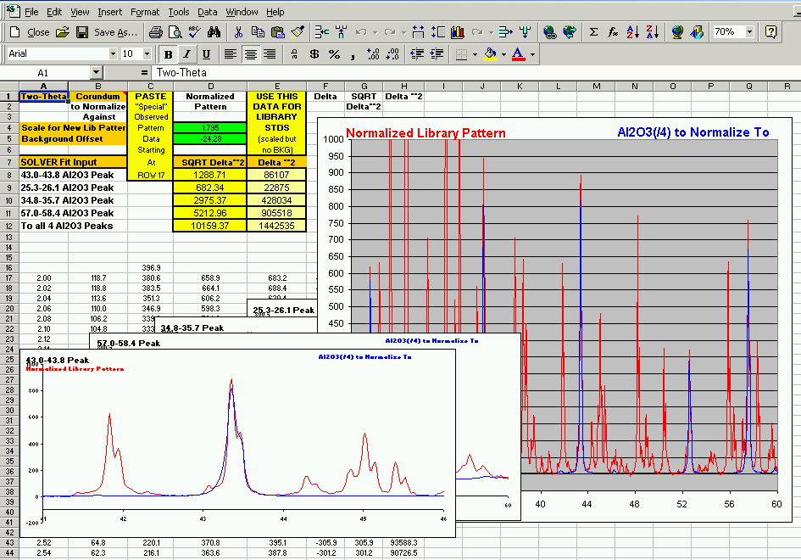
4: Copy the data contained in E17:E3417 and then paste them into the Library Data worksheet (EDIT => PASTE SPECIAL => VALUES) into an empty column, rows 17:3417. Then add the title in row 1 and add a comment (right click on the cell, => edit comment) using one of the existing headings as an example.

PATTERN ADDER: Creation of a Library Standard From Alternate Data Sources
Oftentimes one cannot obtain or does not have sufficient pure sample for use as a library standard. Nevertheless, a library standard can still be generated from alternate data sources using the self-contained worksheet, Pattern Adder, using a pattern for a pure phase (this can be measured, calculated, or simulated from PDF cards) and the RIR for that phase. The procedure for doing this is as follows:

1: Paste the pure-phase pattern into cells D19:D3419.
2: Input the RIR for the phase into cell E10.
3: Input the integrated intensity for the specific peak associated with the RIR into cell E11.
4: The appropriate scale factor for the pattern (displayed in cell E13) is calculated using the formula:

Scale for Observed Pattern = RIR x 178.8 / Peak Intensity of Phase x 4

{178.8 = Intensity of Corundum 43.3 peak for the corundum pattern in FULLPAT}
{x4 to change the traditional 50:50 RIR to the 80:20 ratio used in FULLPAT}

Note: Further normalization of the library patterns using the Lib Pattern Norm worksheet is not required, as the corundum added in this worksheet (Pattern Adder) is already at the proper intensity.

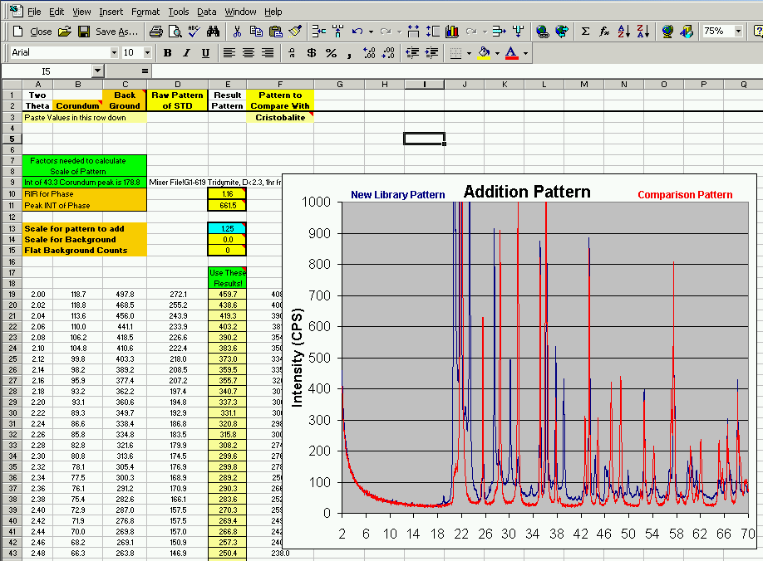
For patterns that were measured on a different instrument, or certainly when calculated or simulated patterns are used, it will be necessary to approximate a representative background. The best way to accomplish this is to manipulate various proportions of a flat and measured background (measured on an empty off-axis-cut quartz plate) so that the combined background compares well with a measured phase of similar chemistry and structure.

5: Copy the library standard for a similar phase (from the standards library) into column F starting at cell F3 (data should be in cells F19:F3419) that will be used for comparison purposes to approximate an appropriate background. For example, if generating a pattern for tridymite, one would like to use quartz or cristobalite for a comparison.

6: Vary the abundances of a measured background (cell E14) and a horizontal background (cell E15) until a reasonable approximation to the comparison phase's background is obtained.
7: Copy the new library standard data (cells E19:E3419) into an empty column of the Library Data worksheet and edit a sample heading using the existing data as an example.

CHUNG: Traditional RIR or CHUNG Analysis
There are times when one encounters a phase for which they do not have a library standard. It may be that they have never needed the standard before, or that it is difficult or impossible to obtain a pattern for the pure phase or cannot be obtained in a timely fashion. In such cases, one can quantify the abundance of this phase using the traditional RIR or Chung analysis (Chung, 1974a,b) using the worksheet entitled CHUNG. An appropriate RIR value can be calculated or can obtained from sources such as the ICDD database or the literature. The Chung worksheet requires the integrated intensity for a peak in the phase, the appropriate RIR (50:50) for that peak, and the integrated intensity for the 43.3 °2θ peak of corundum. CHUNG will convert the RIR value to the 80:20 ratio used by FULLPAT and will calculate the phase abundance on a corundum-free basis. This abundance can then be added manually to the results in the DISPLAY worksheet.

This method works well only if the phase occurs in minor or trace abundance. As the phase is not included in the refinement, FULLPAT will attempt to compensate for its presence by fitting other phases to the peaks of the missing phase.

FUTURE MODIFICATIONS:
Although the least-squares routine works well for fitting library patterns in terms of intensity, we have not yet adopted a least-squares formulation that will compensate for minor shifts in 2θ positions between library patterns and the observed pattern. The SOLVER routine supplied with EXCEL does not accommodate such shifts, although a more sophisticated SOLVER routine can be purchased from a 3rd party vendor that will allow refinement of 2θ shifts during fitting. Several factors contribute to 2θ shifts, including differences in chemistry between library phases and those in the observed pattern, differences in sample packing, sample displacement, and sample transparency, and differences in diffractometer alignment. Currently, minor 2θ shifts are introduced manually.

LEGAL STATEMENT:
This software and ancillary information (herein called “SOFTWARE”) called FULLPAT is made available under the terms described here. The SOFTWARE has been approved for release with associated LA-CC number LA-CC-02-059.

Unless otherwise indicated, this SOFTWARE has been authored by an employee or employees of the University of California, operator of the Los Alamos National Laboratory under Contract No. W-7405-ENG-36 with the U.S. Department of Energy. The U.S. Government has rights to use, reproduce, and distribute this SOFTWARE. The public may copy, distribute, prepare derivative works and publicly display this SOFTWARE without charge, provided that this Notice and any statement of authorship are reproduced on all copies. Neither the Government nor the University makes any warranty, express or implied, or assumes any liability or responsibility for the use of this SOFTWARE.

If SOFTWARE is modified to produce derivative works, such modified SOFTWARE should be clearly marked, so as not to confuse it with the version available from LANL.

REFERENCES:

Bish, D.L. and Chipera, S.J., (1988) Problems and solutions in Quantitative analysis of complex mixtures by X-ray powder diffraction. Advances in X-Ray Analysis, 31, 295-308.

Bish, D.L. and Howard, S.A., (1988) Quantitative phase analysis using the Rietveld method. J. Appl. Cryst., 21, 86-91.

Bish, D.L. and Reynolds, R.C. Jr., (1989) Sample preparation for X-ray diffraction. In Modern Powder Diffraction, D.L. Bish and J.E. Posts, eds. Mineralogical Society of America Reviews in Mineralogy, 20, 73-99.

Bish, D.L., and Chipera, S.J. (1995) Accuracy in quantitative X-ray powder diffraction analyses. In Advances in X-Ray Analysis, 38, P. Predecki et al., Plenum Press, New York, p. 47-57.

Batchelder, M., and Cressey, G. (1998) Rapid, accurate phase quantification of clay-bearing samples using a position-sensitive X-ray detector. Clays and Clay Minerals, 46, 183-194.

Calvert, L.D., Sirianni, A.F., Gainsford, G.J., and Hubbard, C.R. (1983) A comparison of methods for reducing preferred orientation. Adv. X-ray Anal. 26, 105-110.

Chipera, S.J. and Bish, D.L., (1995) Multireflection RIR and intensity normalizations for quantitative analyses: Applications to feldspars and zeolites. Powder Diffraction 10, 47-55.

Chipera, S. J. & Bish, D. L. (2001). FULLPAT: An improved Full-Pattern Quantitative X-ray Diffraction Method. In Proceedings of the 38th Annual Clay Minerals Society Meeting, Madison WI, 105.

Chipera, S.J. and Bish, D.L. (2002) FULLPAT: A Full Pattern Quantitative Analysis Program for X-ray Powder Diffraction, J. App. Cryst. (Accepted for Publication)

Chung, F.H., (1974a) Quantitative interpretation of X-ray diffraction patterns of mixtures. I. Matrix-flushing method for quantitative multicomponent analysis. Journal of Applied Crystallography, 7, 519-525.

Chung F.H., (1974b) Quantitative interpretation of X-ray diffraction patterns of mixtures. II. Adiabatic ,principle of X-ray diffraction analysis of mixtures. Journal of Applied Crystallography, 7, 526- 531.

Clark, G. L. & Reynolds, D. H. (1936) In. Eng. Chem., Anal. Ed., 8, 36-42.

Cressey, G., and Schofield, P.F. (1996) Rapid whole-pattern profile-stripping method for the quantification of multiphase samples. Powder Diffraction, 11, 35-39.

Hill, R.J. and Howard, C.J. (1987) Quantitative phase analysis from neutron powder diffraction data using the Rietveld method. J. Appl. Cryst., 9, 169-174.

Hillier, S., (1999) Use of an air brush to spray dry samples for X-ray powder diffraction. Clay Minerals, 34, 127-135.

Hillier, S., (2000) Accurate quantitative analysis of clay and other minerals in sandstones by XRD: Comparison of a Rietveld and a reference intensity ratio (RIR) method and the importance of sample preparation. Clay Minerals, 35, 291-302.

Hubbard, C.R., Evans E.H., and Smith D.K., (1976) The reference intensity ratio, I/Ic, for computer simulated powder patterns. Journal of Applied Crystallography, 9, 169-174.

Pawloski, G.A., (1985) Quantitative determination of mineral content of geological samples by X-ray diffraction. Am. Mineral. 70, 663-667.

Reynolds, R.C., Jr. (1986) The Lorentz-polarization factor and preferred orientation in oriented clay aggregates. Clay and Clay Minerals, 34, 359-367.

Rietveld, H.M. (1969) A profile refinement method for nuclear and magnetic structures. J. Appl. Cryst. 2, 65-71.

Smith, D.K., M.C. Nichols, and M.E. Zolensky (1983) POWD10, A FORTRAN IV Program for Calculating X-Ray Powder Diffraction Patterns - Version 10, Pennsylvania State University, College of Earth and Mineral Sciences report, University Park, Pennsylvania.

Smith, D.K, Johnson, G.G., Jr., Scheible, A., Wims, A.M., Johnson, J.L. and Ullmann, G. (1987) Quantitative X-ray powder diffraction method using the full diffraction pattern. Powder Diffraction, 2, 73-77.

Smith, S.T., Snyder, R.L., and Brownell, W.E. (1979) Minimization of preferred orientation in powders by spray drying. Adv. X-ray Anal. 22, 77-87.

Snyder, R.L. and Bish, D.L. (1989) Quantitative Analysis. In Modern Powder Diffraction, D.L. Bish and J.E. Posts, eds. Mineralogical Society of America Reviews in Mineralogy, 20, 101-144.

APENDIX I: Phases Distributed in the FULLPAT Standards Library

It is important to recognize when using FULLPAT that the quality of each analysis is strongly dependent on the quality of the standard library patterns. Given the variety of methods and instruments used in different laboratories, library patterns should generally not be shared between different laboratories. FULLPAT is distributed with only a limited number of example library patterns, as individual laboratories should measure their own standard patterns to ensure that the patterns are appropriate for their instrument and sample configurations.

Phase | Sample Source
Albite | Amelia Courthouse, Virginia, WARDS Scientific
Anorthite | Fuggoppe Japan, WARDS Scientific
Apatite | Wilberforce, Ontario, WARDS Scientific
Augite | Harcourt, WARDS Scientific #49E5858
Background | Off-Axis Cut Quartz (zero-background) Plate, Purchased from Gem Duggout
Bytownite | Sonora, Mexico, WARDS Scientific
Calcite | Mallinckrodt Reagent
Clinoptilolite | 27054#1, Fish Creek Mountains, NV, Minerals Research
Corundum | Metallurgical Reagent
Cristobalite | Synthesized from silica gel at 1400°C
Forsterite | Gem Crystals, WARDS Scientific #49-6165
Glass (Rhyolitic) | Drill core USW SD-6, 457.7-458.2 feet depth, Yucca Mountain, NV
Halite | Chemical Reagent
Hematite | Chemical Reagent
Kaolinite | CMS source clay, KGa-2 Kaolinite, Fraction Na-5
Lizardite | Lizardite #47656, Gordon's Quarry NJ
Mordenite | Tokaj Mountains, Hungary, Fraction #1
Orthoclase | West Maroon Pass, CO, WARDS Scientific #49E3080
Opal-A | F99-61, Dixie Valley, NV, collected by F. GOff
Opal-CT | Jalicso, Mexico, WARDS Scientific #46E5880
Quartz | Hot Springs, Arkansas, WARDS Scientific
Sanidine | HU#112914, Eifel Germany
Smect-15Å | CMS source clay, SAz-1, 1-0.35μm, Run at ~50%RH
Smect-12.5Å | CMS source clay, SAz-1, 1-0.35μm, Run at ~1.8%RH
Smect-11.8Å | CMS source clay, SAz-1, 1-0.35μm, Run at ~0.2%RH

Sources of Mineral Standards Listed in the Above Table

Company | Ward's Natural Science Establishment, Inc | Minerals Research | The Clay Minerals Society
Address | P.O. Box 92912  Rochester, NY 14692-9012 | 31 Sherwood Drive  Brockport, New York 14420 | P.O. Box 460130  Aurora, CO 80046-0130
Phone | 800-962-2660 | 585-637-4915 | 303-680-9002
Fax | 800-635-8439 | 585-395-2416 | 303-680-9003
Email |  | fmumpton@frontiernet.net | cms@clays.org
Web Site | http://www.wardsci.com |  | http://cms.lanl.gov

